AZ-900
Creator: Teiryu Email: teiryu@outlook.com

Question 151 Topic 1
You need to manage containers.
Which two services can you use? Each correct answer presents a complete solution.
NOTE: Each correct selection is worth one point.
A. Azure Virtual Desktop
B. Azure virtual machines
C. Azure Functions
D. Azure Container Instances
E. Azure Kubernetes Service (AKS)
Answer: DE
Voted Answer: DE

Question 152 Topic 1
HOTSPOT -
To complete the sentence, select the appropriate option in the answer area.
Hot Area:
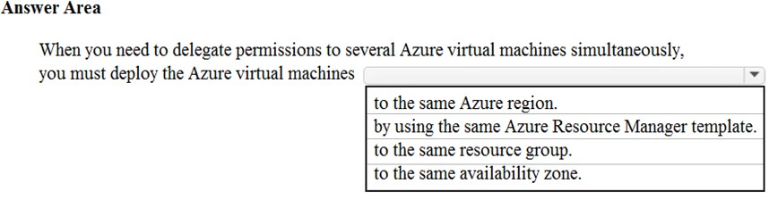

Answer:
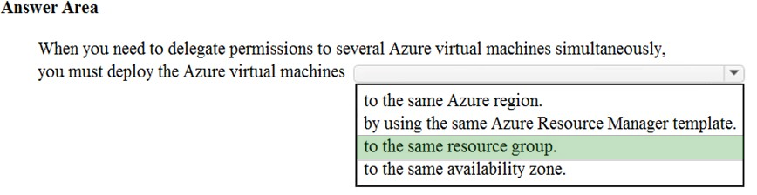

Question 153 Topic 1
Note: This question is part of a series of questions that present the same scenario. Each question in the series contains a unique solution that might meet the stated goals. Some question sets might have more than one correct solution, while others might not have a correct solution.
After you answer a question in this section, you will NOT be able to return to it. As a result, these questions will not appear in the review screen.
You plan to deploy several Azure virtual machines.
You need to ensure that the services running on the virtual machines are available if a single data center fails.
Solution: You deploy the virtual machines to two or more availability zones.
Does this meet the goal?
A. Yes
B. No
Answer: A
Voted Answer: A

Question 154 Topic 1
This question requires that you evaluate the underlined text to determine if it is correct.
One of the benefits of Azure SQL Data Warehouse is that high availability is built into the platform.
Instructions: Review the underlined text. If it makes the statement correct, select `No change is needed`. If the statement is incorrect, select the answer choice that makes the statement correct.
A. No change is needed
B. automatic scaling
C. data compression
D. versioning
Answer: A
Voted Answer: A

Question 155 Topic 1
Note: This question is part of a series of questions that present the same scenario. Each question in the series contains a unique solution that might meet the stated goals. Some question sets might have more than one correct solution, while others might not have a correct solution.
After you answer a question in this section, you will NOT be able to return to it. As a result, these questions will not appear in the review screen.
You plan to deploy several Azure virtual machines.
You need to ensure that the services running on the virtual machines are available if a single data center fails.
Solution: You deploy the virtual machines to two or more regions.
Does this meet the goal?
A. Yes
B. No
Answer: A
Voted Answer: A

Question 156 Topic 1
HOTSPOT -
Select the answer that correctly completes the sentence.
Hot Area:
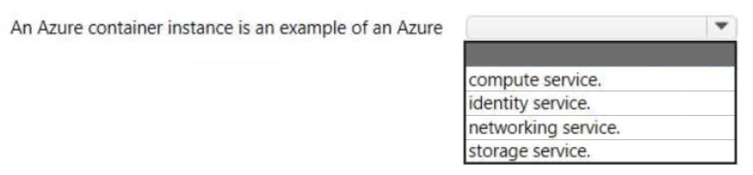

Answer:
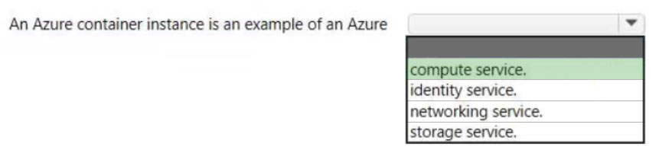

Question 157 Topic 1
At which OSI layer does ExpressRoute operate?
A. Layer 2
B. Layer 3
C. Layer 5
D. Layer 7
Answer: B
Voted Answer: B

Question 158 Topic 1
HOTSPOT -
Select the answer that correctly completes the sentence.
Hot Area:
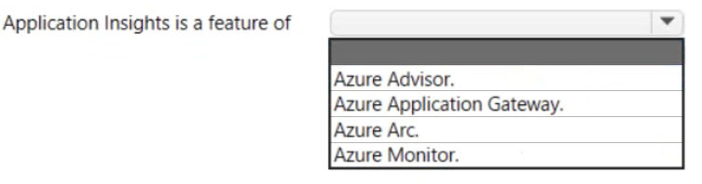

Answer:
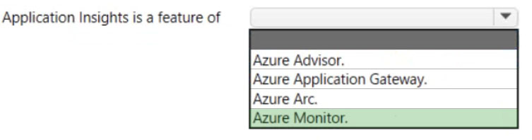

Question 159 Topic 1
HOTSPOT -
For each of the following statements, select Yes if the statement is true. Otherwise, select No.
NOTE: Each correct selection is worth one point.
Hot Area:
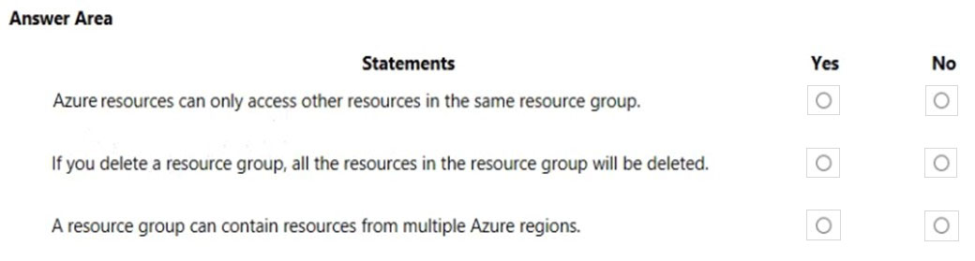

Answer:
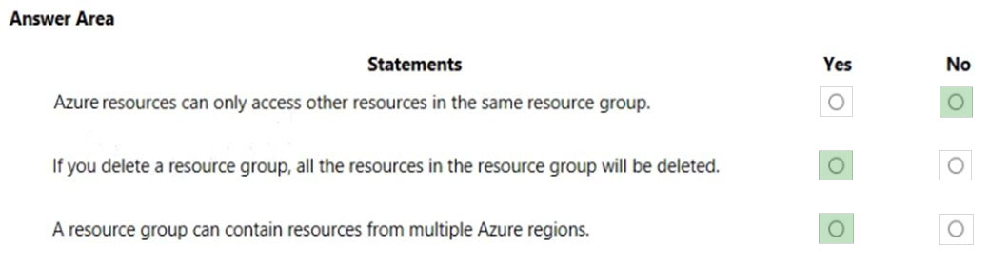

Question 160 Topic 1
You plan to store 20 TB of data in Azure. The data will be accessed infrequently and visualized by using Microsoft Power BI.
You need to recommend a storage solution for the data.
Which two solutions should you recommend? Each correct answer presents a complete solution.
NOTE: Each correct selection is worth one point.
A. Azure Data Lake
B. Azure Cosmos DB
C. Azure SQL Data Warehouse
D. Azure SQL Database
E. Azure Database for PostgreSQL
Answer: AC
Voted Answer: AC

Question 161 Topic 1
HOTSPOT -
You have an Azure environment that contains 10 web apps. To which URL should you connect to manage all the Azure resources? To answer, select the appropriate options in the answer area.
NOTE: Each correct selection is worth one point.
Hot Area:
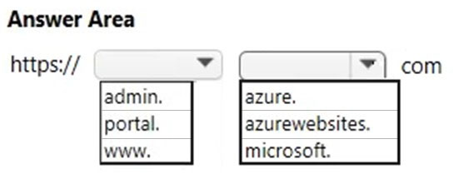

Answer:
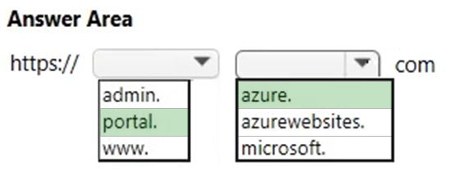

Question 162 Topic 1
DRAG DROP -
Arrange the storage account redundancy options from the least redundant to the most redundant. To answer, move all options from the list of options to the answer area and arrange them in the correct order.
Select and Place:
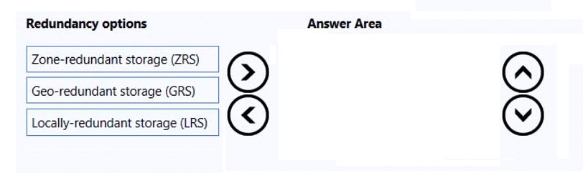

Answer:
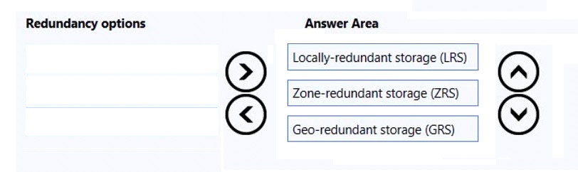

Question 163 Topic 1
HOTSPOT -
Select the answer that correctly completes the sentence.
Hot Area:
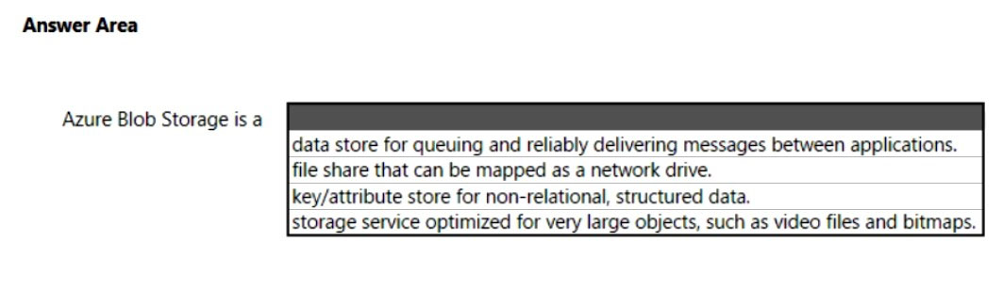

Answer:
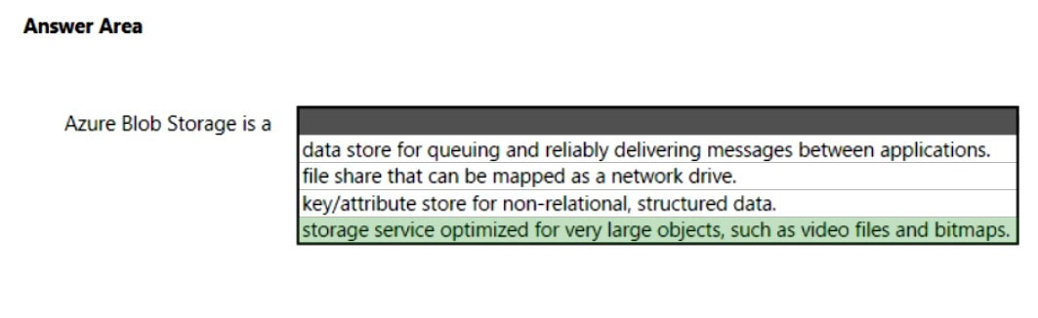

Question 164 Topic 1
Note: This question is part of a series of questions that present the same scenario. Each question in the series contains a unique solution that might meet the stated goals. Some question sets might have more than one correct solution, while others might not have a correct solution.
After you answer a question in this section, you will NOT be able to return to it. As a result, these questions will not appear in the review screen.
An Azure administrator plans to run a PowerShell script that creates Azure resources.
You need to recommend which computer configuration to use to run the script.
Solution: Run the script from a computer that runs Linux and has the Azure CLI tools installed.
Does this meet the goal?
A. Yes
B. No
Answer: B
Voted Answer: B

Question 165 Topic 1
Note: This question is part of a series of questions that present the same scenario. Each question in the series contains a unique solution that might meet the stated goals. Some question sets might have more than one correct solution, while others might not have a correct solution.
After you answer a question in this section, you will NOT be able to return to it. As a result, these questions will not appear in the review screen.
An Azure administrator plans to run a PowerShell script that creates Azure resources.
You need to recommend which computer configuration to use to run the script.
Solution: Run the script from a computer that runs Chrome OS and uses Azure Cloud Shell.
Does this meet the goal?
A. Yes
B. No
Answer: A
Voted Answer: A

Question 166 Topic 1
HOTSPOT -
For each of the following statements, select Yes if the statement is true. Otherwise, select No.
NOTE: Each correct selection is worth one point.
Hot Area:
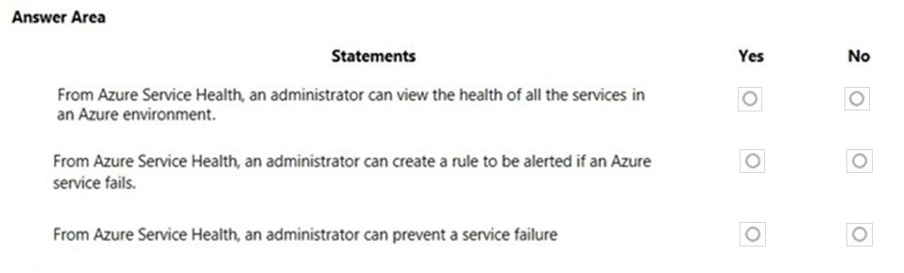

Answer:
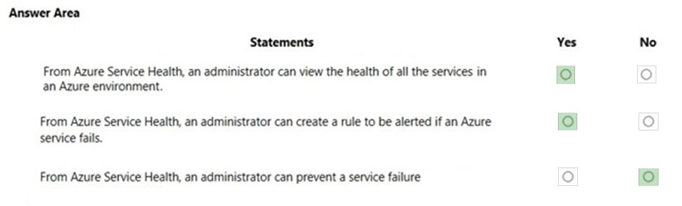

Question 167 Topic 1
Note: This question is part of a series of questions that present the same scenario. Each question in the series contains a unique solution that might meet the stated goals. Some question sets might have more than one correct solution, while others might not have a correct solution.
After you answer a question in this section, you will NOT be able to return to it. As a result, these questions will not appear in the review screen.
An Azure administrator plans to run a PowerShell script that creates Azure resources.
You need to recommend which computer configuration to use to run the script.
Solution: Run the script from a computer that runs macOS and has PowerShell Core 6.0 installed.
Does this meet the goal?
A. Yes
B. No
Answer: B
Voted Answer: B

Question 168 Topic 1
HOTSPOT -
You need to view a list of planned maintenance events that can affect the availability of an Azure subscription.
Which blade should you use from the Azure portal? To answer, select the appropriate blade in the answer area.
Hot Area:
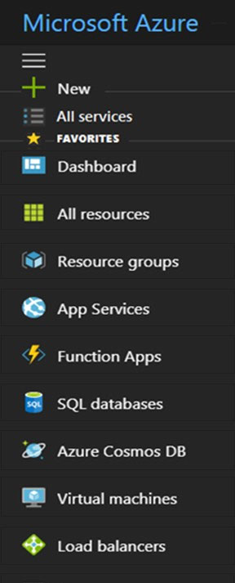

Answer:

Question 169 Topic 1
DRAG DROP -
Match the Azure service to the correct definition.
Instructions: To answer, drag the appropriate Azure service from the column on the left to its description on the right. Each service may be used once, more than once, or not at all.
NOTE: Each correct match is worth one point.
Select and Place:
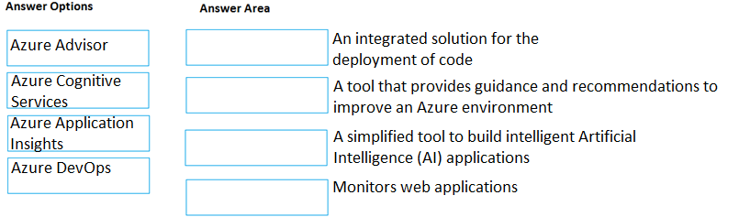

Answer:
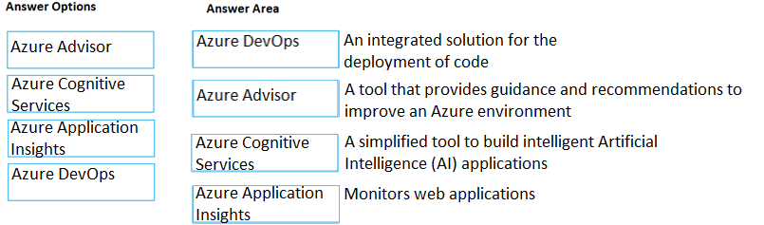

Question 170 Topic 1
DRAG DROP -
Match the Azure service to the correct description.
Instructions: To answer, drag the appropriate Azure service from the column on the left to its description on the right. Each service may be used once, more than once, or not at all.
NOTE: Each correct match is worth one point.
Select and Place:
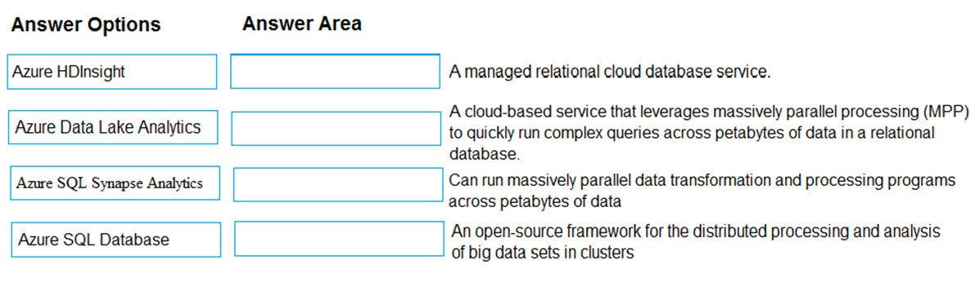

Answer:
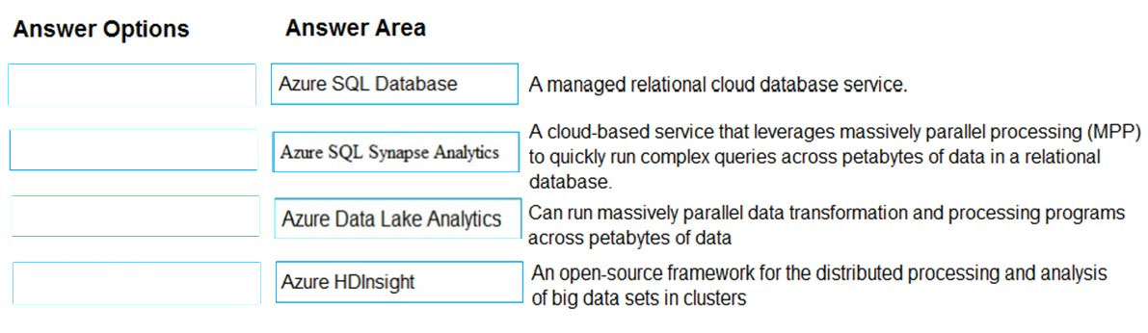

Question 171 Topic 1
HOTSPOT -
You need to identify which blades in the Azure portal must be used to perform the following tasks:
✑ View security recommendations.
✑ Monitor the health of Azure services.
✑ Browse available virtual machine images.
Which blade should you identify for each task? To answer, select the appropriate options in the answer area.
NOTE: Each correct selection is worth one point.
Hot Area:
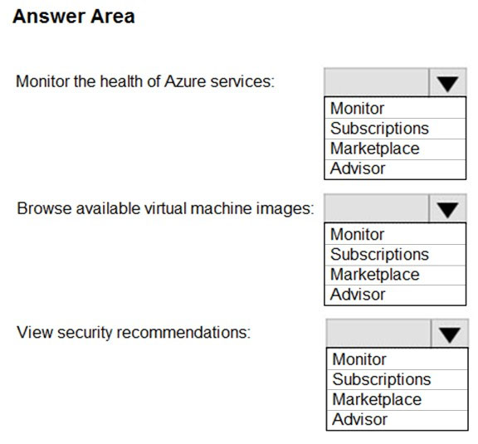

Answer:
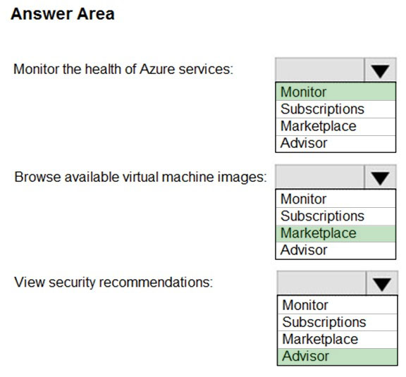

Question 172 Topic 1
Note: This question is part of a series of questions that present the same scenario. Each question in the series contains a unique solution that might meet the stated goals. Some question sets might have more than one correct solution, while others might not have a correct solution.
After you answer a question in this section, you will NOT be able to return to it. As a result, these questions will not appear in the review screen.
You have an Azure environment. You need to create a new Azure virtual machine from a tablet that runs the Android operating system.
Solution: You use Bash in Azure Cloud Shell.
Does this meet the goal?
A. Yes
B. No
Answer: A
Voted Answer: A

Question 173 Topic 1
You have an on-premises application that sends email notifications automatically based on a rule.
You plan to migrate the application to Azure.
You need to recommend a serverless computing solution for the application.
What should you include in the recommendation?
A. a web app
B. a server image in Azure Marketplace
C. a logic app
D. an API app
Answer: C
Voted Answer: C

Question 174 Topic 1
You plan to deploy a website to Azure. The website will be accessed by users worldwide and will host large video files.
You need to recommend which Azure feature must be used to provide the best video playback experience.
What should you recommend?
A. an application gateway
B. an Azure ExpressRoute circuit
C. a content delivery network (CDN)
D. an Azure Traffic Manager profile
Answer: C
Voted Answer: C

Question 175 Topic 1
Your company plans to deploy several million sensors that will upload data to Azure.
You need to identify which Azure resources must be created to support the planned solution.
Which two Azure resources should you identify? Each correct answer presents part of the solution.
NOTE: Each correct selection is worth one point.
A. Azure Data Lake
B. Azure Queue storage
C. Azure File Storage
D. Azure IoT Hub
E. Azure Notification Hubs
Answer: AD
Voted Answer: AD

Question 176 Topic 1
You have an Azure web app.
You need to manage the settings of the web app from an iPhone.
What are two Azure management tools that you can use? Each correct answer presents a complete solution.
NOTE: Each correct selection is worth one point.
A. Azure CLI
B. the Azure portal
C. Azure Cloud Shell
D. Windows PowerShell
E. Azure Storage Explorer
Answer: BC
Voted Answer: BC

Question 177 Topic 1
Your company plans to deploy an Artificial Intelligence (AI) solution in Azure.
What should the company use to build, test, and deploy predictive analytics solutions?
A. Azure Logic Apps
B. Azure Machine Learning Designer
C. Azure Batch
D. Azure Cosmos DB
Answer: B
Voted Answer: B

Question 178 Topic 1
HOTSPOT -
For each of the following statements, select Yes if the statement is true. Otherwise, select No.
NOTE: Each correct selection is worth one point.
Hot Area:
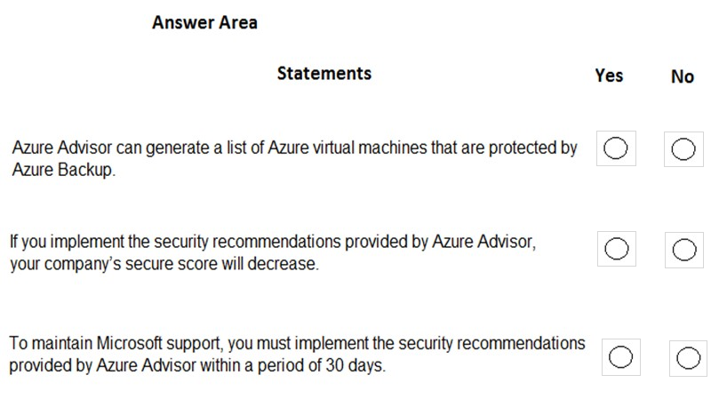

Answer:
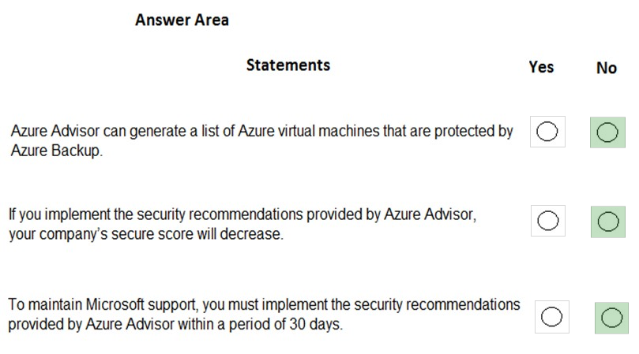

Question 179 Topic 1
What can you use to automatically send an alert if an administrator stops an Azure virtual machine?
A. Azure Advisor
B. Azure Service Health
C. Azure Monitor
D. Azure Network Watcher
Answer: C
Voted Answer: C

Question 180 Topic 1
DRAG DROP -
Match the Azure services to the correct descriptions.
Instructions: To answer, drag the appropriate Azure service from the column on the left to its description on the right. Each service may be used once, more than once, or not at all.
NOTE: Each correct match is worth one point
Select and Place:
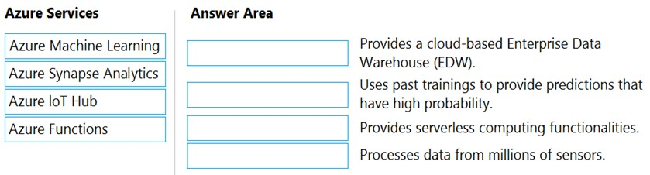

Answer:
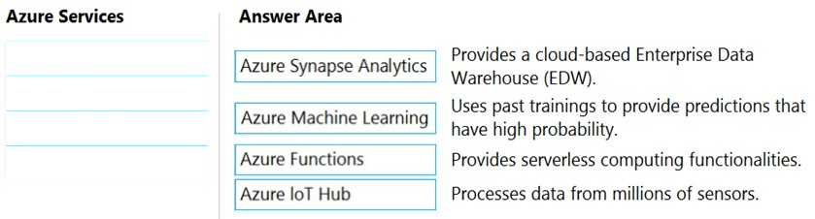

Question 181 Topic 1
You have an Azure environment.
You need to create a new Azure virtual machine from a tablet that runs the Android operating system.
What are three possible solutions? Each correct answer presents a complete solution.
NOTE: Each correct selection is worth one point.
A. Use Bash in Azure Cloud Shell.
B. Use PowerShell in Azure Cloud Shell.
C. Use the PowerApps portal.
D. Use the Security & Compliance admin center.
E. Use the Azure portal.
Answer: ABE
Voted Answer: ABE

Question 182 Topic 1
A team of developers at your company plans to deploy, and then remove, 50 virtual machines each week. All the virtual machines are configured by using Azure
Resource Manager templates.
You need to recommend which Azure service will minimize the administrative effort required to deploy and remove the virtual machines.
What should you recommend?
A. Azure Reserved Virtual Machine (VM) Instances
B. Azure DevTest Labs
C. Azure virtual machine scale sets
D. Azure Virtual Desktop
Answer: B
Voted Answer: B

Question 183 Topic 1
HOTSPOT -
For each of the following statements, select Yes if the statement is true. Otherwise, select No.
NOTE: Each correct selection is worth one point.
Hot Area:
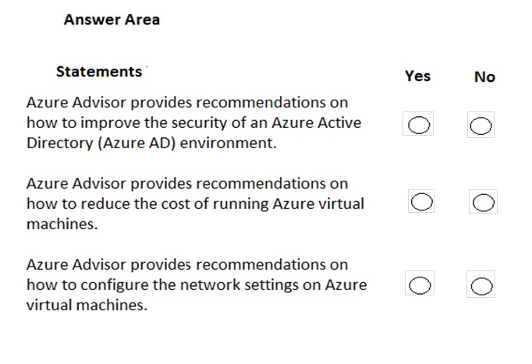

Answer:
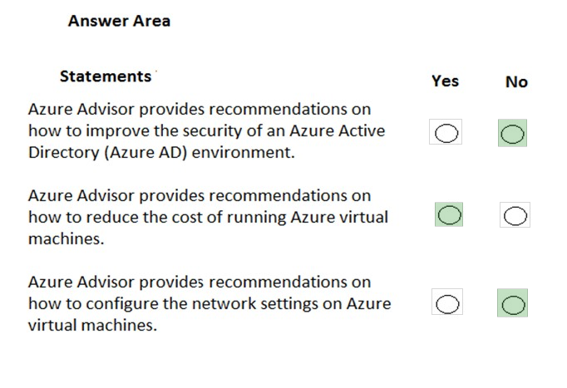

Question 184 Topic 1
Note: This question is part of a series of questions that present the same scenario. Each question in the series contains a unique solution that might meet the stated goals. Some question sets might have more than one correct solution, while others might not have a correct solution.
After you answer a question in this section, you will NOT be able to return to it. As a result, these questions will not appear in the review screen.
You have an Azure subscription named Subscription1. You sign in to the Azure portal and create a resource group named RG1.
From Azure documentation, you have the following command that creates a virtual machine named VM1. az vm create --resource-group RG1 --name VM1 --image UbuntuLTS --generate-ssh-keys
You need to create VM1 in Subscription1 by using the command.
Solution: From the Azure portal, launch Azure Cloud Shell and select PowerShell. Run the command in Cloud Shell.
Does this meet the goal?
A. Yes
B. No
Answer: A
Voted Answer: A

Question 185 Topic 1
Note: This question is part of a series of questions that present the same scenario. Each question in the series contains a unique solution that might meet the stated goals. Some question sets might have more than one correct solution, while others might not have a correct solution.
After you answer a question in this section, you will NOT be able to return to it. As a result, these questions will not appear in the review screen.
You have an Azure subscription named Subscription1. You sign in to the Azure portal and create a resource group named RG1.
From Azure documentation, you have the following command that creates a virtual machine named VM1. az vm create --resource-group RG1 --name VM1 --image UbuntuLTS
--generate-ssh-keys
You need to create VM1 in Subscription1 by using the command.
Solution: From a computer that runs Windows 10, install Azure CLI. From PowerShell, sign in to Azure and then run the command.
Does this meet the goal?
A. Yes
B. No
Answer: A
Voted Answer: A

Question 186 Topic 1
Note: This question is part of a series of questions that present the same scenario. Each question in the series contains a unique solution that might meet the stated goals. Some question sets might have more than one correct solution, while others might not have a correct solution.
After you answer a question in this section, you will NOT be able to return to it. As a result, these questions will not appear in the review screen.
You have an Azure subscription named Subscription1. You sign in to the Azure portal and create a resource group named RG1.
From Azure documentation, you have the following command that creates a virtual machine named VM1. az vm create --resource-group RG1 --name VM1 --image UbuntuLTS
--generate-ssh-keys
You need to create VM1 in Subscription1 by using the command.
Solution: From a computer that runs Windows 10, install Azure CLI. From a command prompt, sign in to Azure and then run the command.
Does this meet the goal?
A. Yes
B. No
Answer: A
Voted Answer: A

Question 187 Topic 1
HOTSPOT -
Several support engineers plan to manage Azure by using the computers shown in the following table:
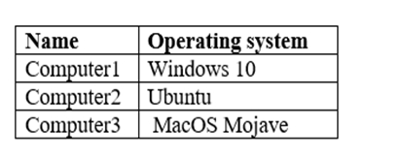
You need to identify which Azure management tools can be used from each computer.
What should you identify for each computer? To answer, select the appropriate options in the answer area.
NOTE: Each correct selection is worth one point.
Hot Area:
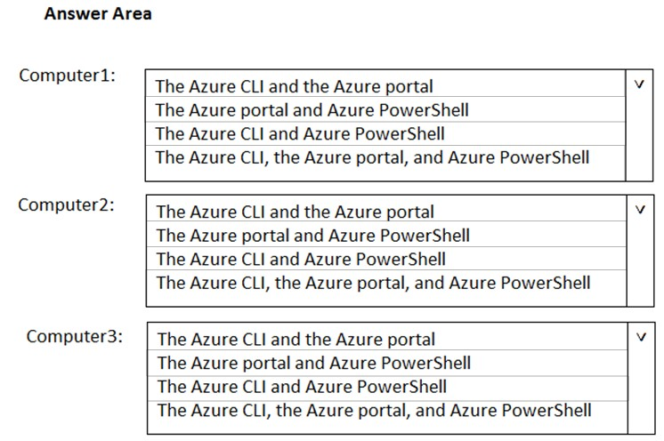

Answer:
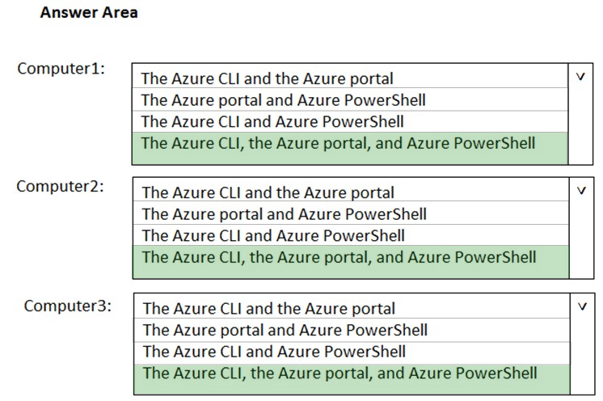

Question 188 Topic 1
HOTSPOT -
To complete the sentence, select the appropriate option in the answer area.
Hot Area:
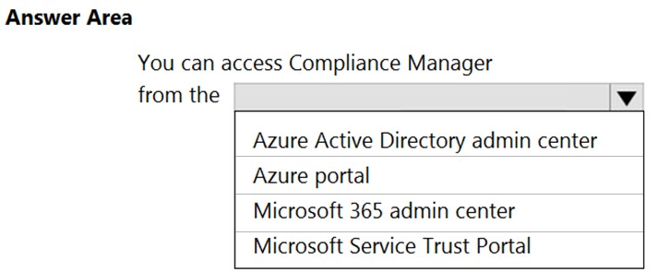

Answer:
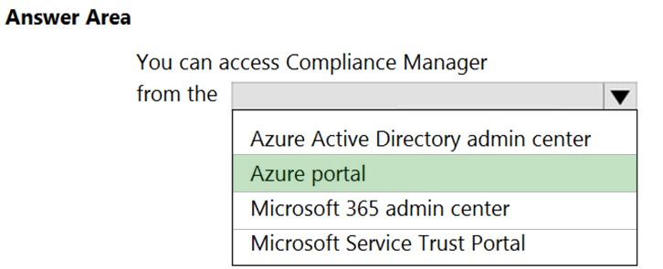

Question 189 Topic 1
HOTSPOT -
To complete the sentence, select the appropriate option in the answer area.
Hot Area:
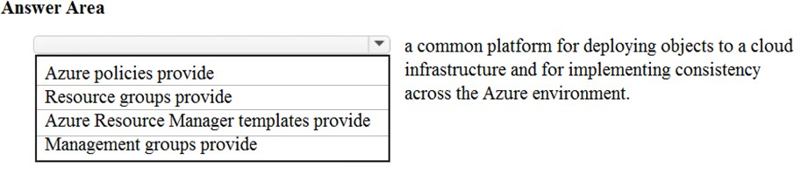

Answer:
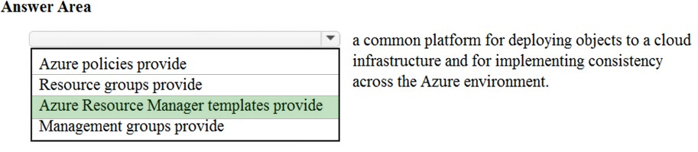

Question 190 Topic 1
DRAG DROP -
Match the Azure service to the correct description.
Instructions: To answer, drag the appropriate Azure service from the column on the left to its description on the right. Each service may be used once, more than once, or not at all.
NOTE: Each correct selection is worth one point.
Select and Place:
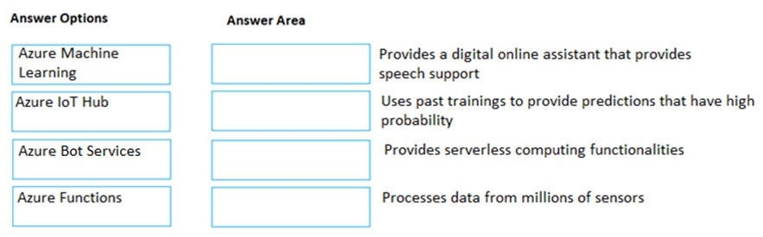

Answer:
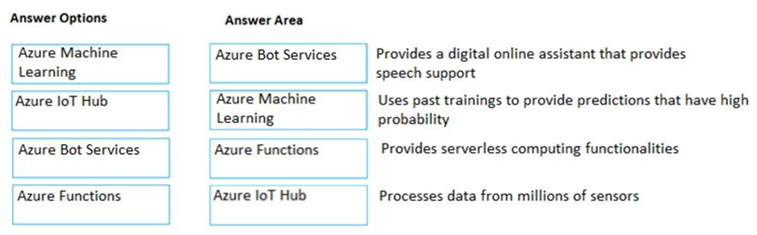

Question 191 Topic 1
Note: This question is part of a series of questions that present the same scenario. Each question in the series contains a unique solution that might meet the stated goals. Some question sets might have more than one correct solution, while others might not have a correct solution.
After you answer a question in this section, you will NOT be able to return to it. As a result, these questions will not appear in the review screen.
An Azure administrator plans to run a PowerShell script that creates Azure resources.
You need to recommend which computer configuration to use to run the script.
Solution: Run the script from a computer that runs Windows 10 and has the Azure PowerShell module installed.
Does this meet the goal?
A. Yes
B. No
Answer: A
Voted Answer: A

Question 192 Topic 1
DRAG DROP -
Match the Azure services to the correct description.
Instructions: To answer, drag the appropriate Azure service from the column on the left to its description on the right. Each service may be used once, more than once, or not at all.
NOTE: Each correct selection is worth one point.
Select and Place:
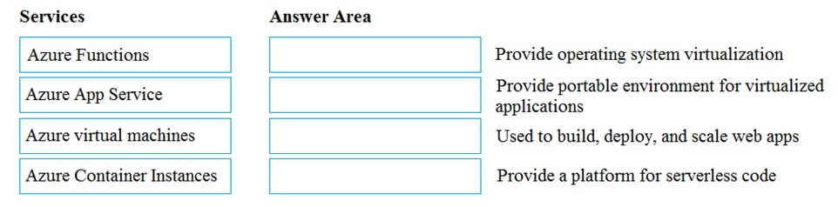

Answer:
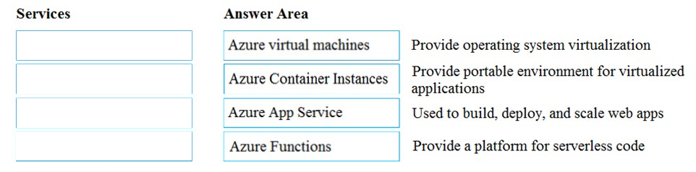

Question 193 Topic 1
Which service provides serverless computing in Azure?
A. Azure Virtual Machines
B. Azure Functions
C. Azure storage account
D. Azure dedicated hosts
Answer: B
Voted Answer: B

Question 194 Topic 1
An Azure administrator plans to run a PowerShell script that creates Azure resources.
You need to recommend which computer configuration to use to run the script.
Which three computers can run the script? Each correct answer presents a complete solution.
NOTE: Each correct selection is worth one point.
A. a computer that runs macOS and has PowerShell Core 6.0 installed.
B. a computer that runs Windows 10 and has the Azure PowerShell module installed.
C. a computer that runs Linux and has the Azure PowerShell module installed.
D. a computer that runs Linux and has the Azure CLI tools installed.
E. a computer that runs Chrome OS and uses Azure Cloud Shell.
Answer: BCE
Voted Answer: BCE

Question 195 Topic 1
Note: This question is part of a series of questions that present the same scenario. Each question in the series contains a unique solution that might meet the stated goals. Some question sets might have more than one correct solution, while others might not have a correct solution.
After you answer a question in this section, you will NOT be able to return to it. As a result, these questions will not appear in the review screen.
You have an Azure subscription named Subscription1. You sign in to the Azure portal and create a resource group named RG1.
From Azure documentation, you have the following command that creates a virtual machine named VM1. az vm create --resource-group RG1 --name VM1 --image UbuntuLTS --generate-ssh-keys
You need to create VM1 in Subscription1 by using the command.
Solution: From the Azure portal, launch Azure Cloud Shell and select Bash. Run the command in Cloud Shell.
Does this meet the goal?
A. Yes
B. No
Answer: A
Voted Answer: A

Question 196 Topic 1
Your company has several business units.
Each business unit requires 20 different Azure resources for daily operation. All the business units require the same type of Azure resources.
You need to recommend a solution to automate the creation of the Azure resources.
What should you include in the recommendations?
A. Azure Resource Manager templates
B. virtual machine scale sets
C. the Azure API Management service
D. management groups
Answer: A
Voted Answer: A

Question 197 Topic 1
HOTSPOT -
For each of the following statements, select Yes if the statement is true. Otherwise, select No.
NOTE: Each correct selection is worth one point.
Hot Area:
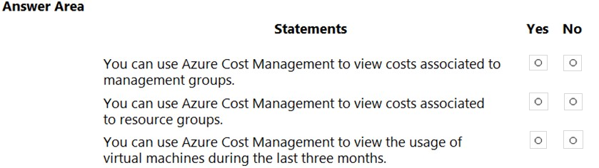

Answer:
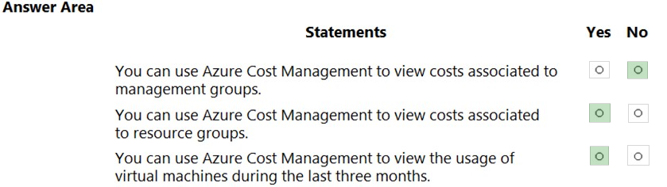

Question 198 Topic 1
What can you use to identify underutilized or unused Azure virtual machines?
A. Azure Advisor
B. Azure Cost Management + Billing
C. Azure reservations
D. Azure Policy
Answer: A
Voted Answer: A

Question 199 Topic 1
HOTSPOT -
Which node in the Azure portal should you use to assign a user the Reader role for a resource group? To answer, select the node in the answer area.
NOTE: Each correct selection is worth one point.
Hot Area:
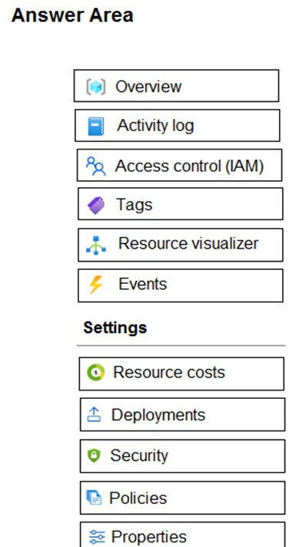

Answer:
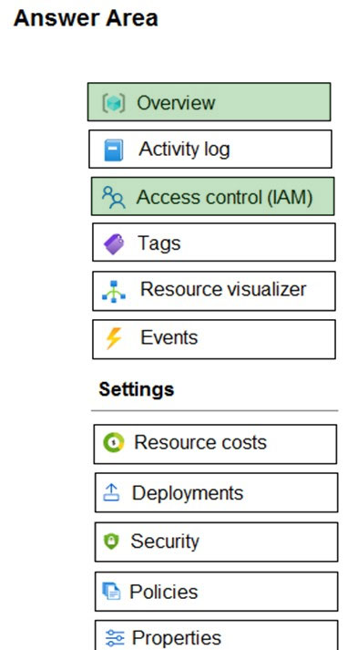

Question 200 Topic 1
HOTSPOT -
For each of the following statements, select Yes if the statement is true. Otherwise, select No.
NOTE: Each correct selection is worth one point.
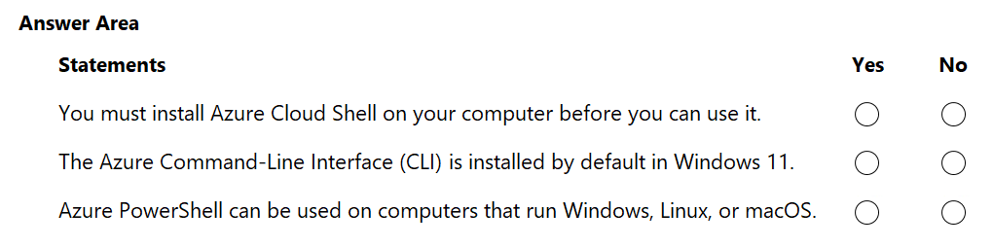
Answer:
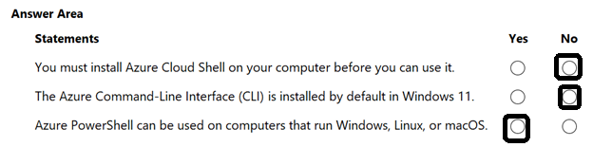

Question 201 Topic 1
HOTSPOT -
For each of the following statements, select Yes if the statement is true. Otherwise, select No.
NOTE: Each correct selection is worth one point.
Hot Area:
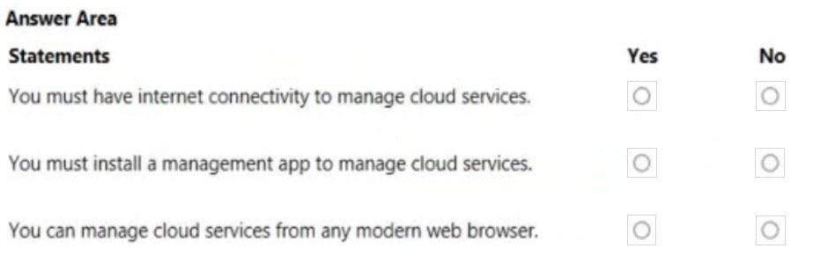

Answer:
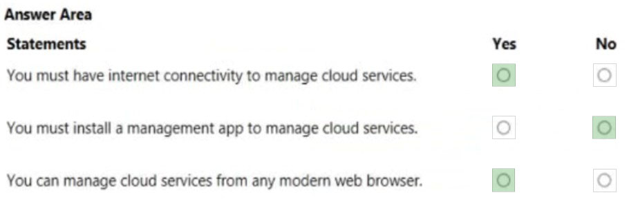

Question 202 Topic 1
DRAG DROP -
Match the Azure service to the correct definition.
Instructions: To answer, drag the appropriate Azure service from the column on the left to its description on the right. Each service may be used once, more than once, or not at all.
NOTE: Each correct selection is worth one point.
Select and Place:
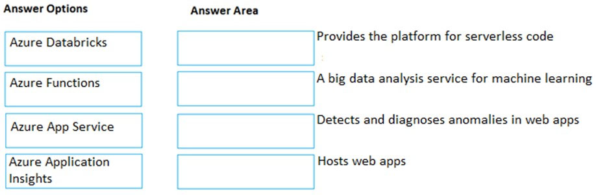

Answer:
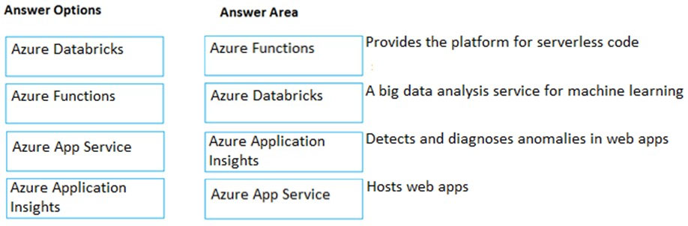

Question 203 Topic 1
A team of developers at your company plans to deploy, and then remove, 50 customized virtual machines each week. Thirty of the virtual machines run Windows
Server 2016 and 20 of the virtual machines run Ubuntu Linux.
You need to recommend which Azure service will minimize the administrative effort required to deploy and remove the virtual machines.
What should you recommend?
A. Azure Reserved Virtual Machines (VM) Instances
B. Azure virtual machine scale sets
C. Azure DevTest Labs
D. Microsoft Managed Desktop
Answer: C
Voted Answer: C

Question 204 Topic 1
HOTSPOT -
For each of the following statements, select Yes if the statement is true. Otherwise, select No.
NOTE: Each correct selection is worth one point.
Hot Area:
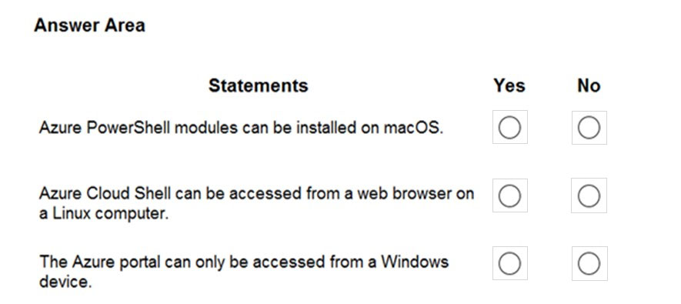

Answer:
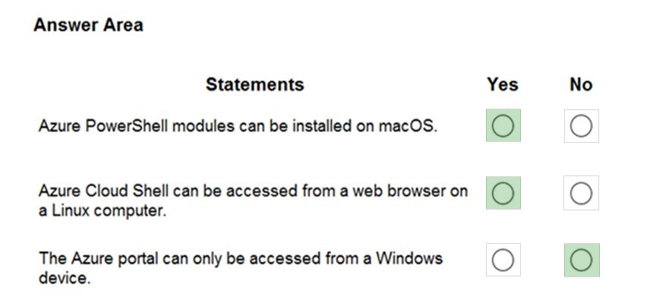

Question 205 Topic 1
A support engineer plans to perform several Azure management tasks by using the Azure CLI.
You install the CLI on a computer.
You need to tell the support engineer which tools to use to run the CLI.
Which two tools should you instruct the support engineer to use? Each correct answer presents a complete solution.
NOTE: Each correct selection is worth one point.
A. Command Prompt
B. Azure Resource Explorer
C. Windows PowerShell
D. Windows Defender Firewall
E. Network and Sharing Center
Answer: AC
Voted Answer: AC

Question 206 Topic 1
Note: This question is part of a series of questions that present the same scenario. Each question in the series contains a unique solution that might meet the stated goals. Some question sets might have more than one correct solution, while others might not have a correct solution.
After you answer a question in this section, you will NOT be able to return to it. As a result, these questions will not appear in the review screen.
You have an Azure environment. You need to create a new Azure virtual machine from a tablet that runs the Android operating system.
Solution: You use PowerShell in Azure Cloud Shell.
Does this meet the goal?
A. Yes
B. No
Answer: A
Voted Answer: A

Question 207 Topic 1
Note: This question is part of a series of questions that present the same scenario. Each question in the series contains a unique solution that might meet the stated goals. Some question sets might have more than one correct solution, while others might not have a correct solution.
After you answer a question in this section, you will NOT be able to return to it. As a result, these questions will not appear in the review screen.
You have an Azure environment. You need to create a new Azure virtual machine from a tablet that runs the Android operating system.
Solution: You use the PowerApps portal.
Does this meet the goal?
A. Yes
B. No
Answer: B
Voted Answer: B

Question 208 Topic 1
Note: This question is part of a series of questions that present the same scenario. Each question in the series contains a unique solution that might meet the stated goals. Some question sets might have more than one correct solution, while others might not have a correct solution.
After you answer a question in this section, you will NOT be able to return to it. As a result, these questions will not appear in the review screen.
You have an Azure environment. You need to create a new Azure virtual machine from a tablet that runs the Android operating system.
Solution: You use the Azure portal.
Does this meet the goal?
A. Yes
B. No
Answer: A
Voted Answer: A

Question 209 Topic 1
HOTSPOT -
Select the answer that correctly completes the sentence.
Hot Area:
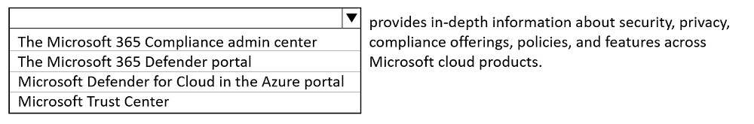

Answer:
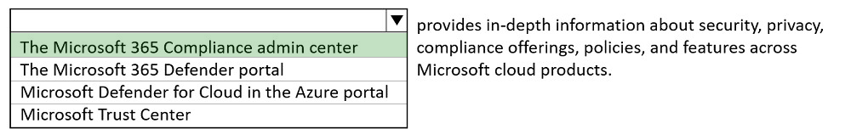

Question 210 Topic 1
HOTSPOT -
Select the answer that correctly completes the sentence.
Hot Area:
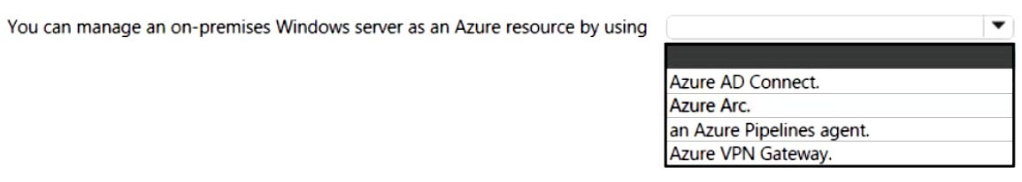

Answer:
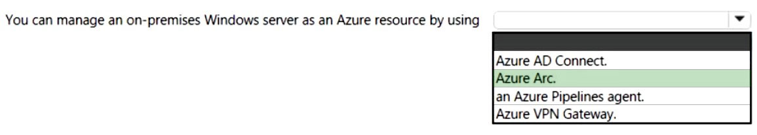

Question 211 Topic 1
HOTSPOT -
For each of the following statements, select Yes if the statement is true. Otherwise, select No.
NOTE: Each correct selection is worth one point.
Hot Area:
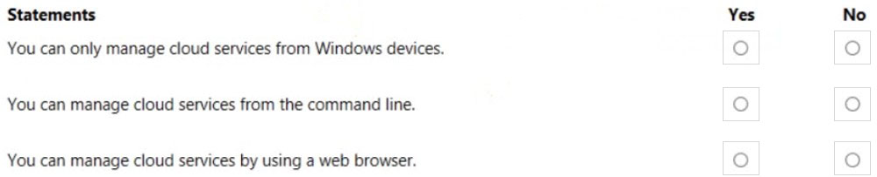

Answer:
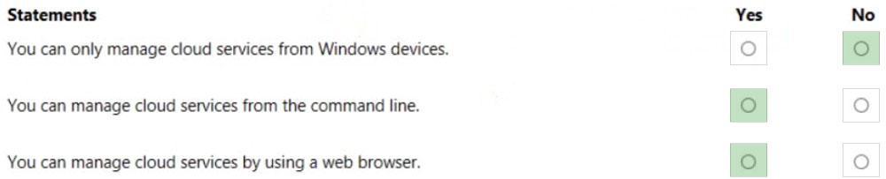

Question 212 Topic 1
HOTSPOT -
To complete the sentence, select the appropriate option in the answer area.
Hot Area:
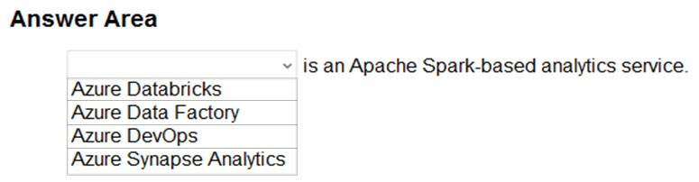

Answer:
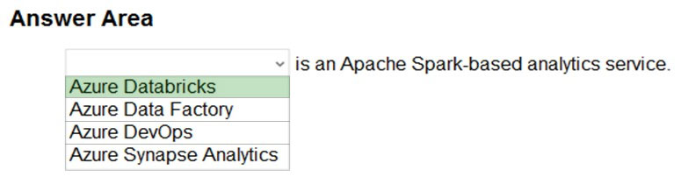

Question 213 Topic 1
HOTSPOT -
For each of the following statements, select Yes if the statement is true. Otherwise, select No.
NOTE: Each correct selection is worth one point.
Hot Area:
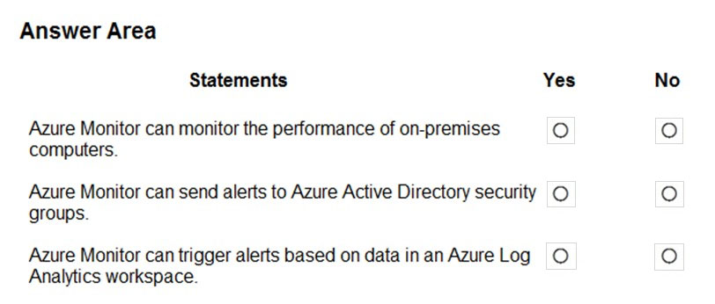

Answer:
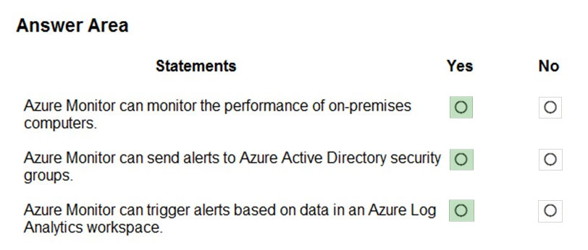

Question 214 Topic 1
Which Azure service provides a set of version control tools to manage code?
A. Azure Repos
B. Azure DevTest Labs
C. Azure Storage
D. Azure Cosmos DB
Answer: A
Voted Answer: A

Question 215 Topic 1
HOTSPOT -
You need to manage Azure by using Azure Cloud Shell.
Which Azure portal icon should you select? To answer, select the appropriate icon in the answer area.
Hot Area:
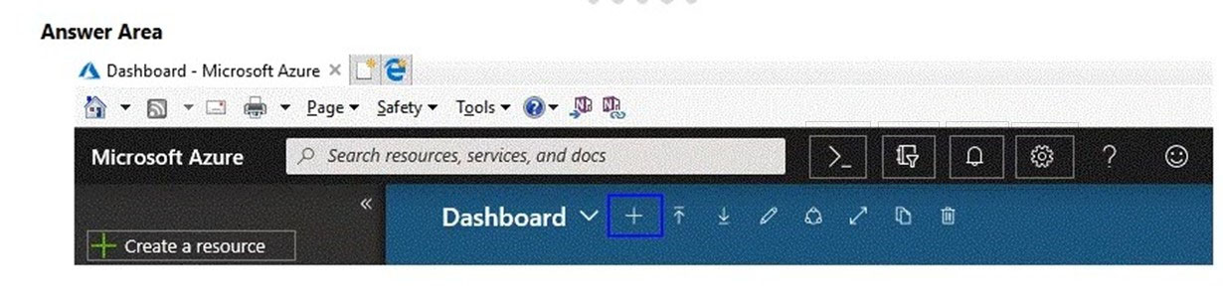

Answer:
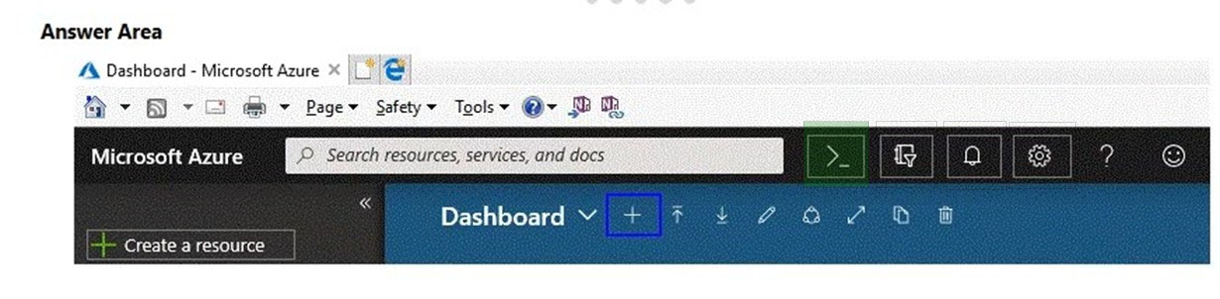

Question 216 Topic 1
You have a virtual machine named VM1 that runs Windows Server 2016. VM1 is in the East US Azure region.
Which Azure service should you use from the Azure portal to view service failure notifications that can affect the availability of VM1?
A. Azure Service Fabric
B. Azure Monitor
C. Azure virtual machines
D. Azure Advisor
Answer: B
Voted Answer: B

Question 217 Topic 1
Note: This question is part of a series of questions that present the same scenario. Each question in the series contains a unique solution that might meet the stated goals. Some question sets might have more than one correct solution, while others might not have a correct solution.
After you answer a question in this section, you will NOT be able to return to it. As a result, these questions will not appear in the review screen.
Your Azure environment contains multiple Azure virtual machines.
You need to ensure that a virtual machine named VM1 is accessible from the Internet over HTTP.
Solution: You modify an Azure Traffic Manager profile.
Does this meet the goal?
A. Yes
B. No
Answer: B
Voted Answer: B

Question 218 Topic 1
Your company plans to deploy several web servers and several database servers to Azure.
You need to recommend an Azure solution to limit the types of connections from the web servers to the database servers.
What should you include in the recommendation?
A. network security groups (NSGs)
B. Azure Service Bus
C. a local network gateway
D. a route filter
Answer: A
Voted Answer: A

Question 219 Topic 1
HOTSPOT -
To complete the sentence, select the appropriate option in the answer area.
Hot Area:
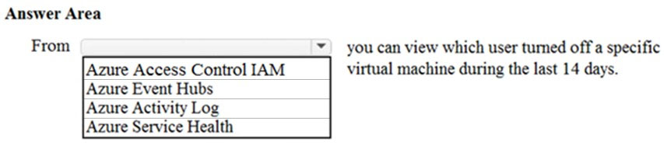

Answer:
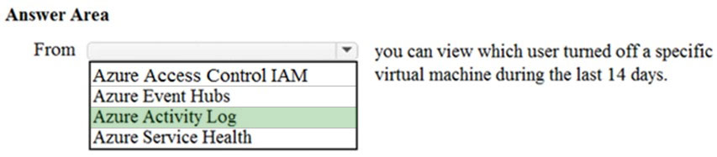

Question 220 Topic 1
Which service provides network traffic filtering across multiple Azure subscriptions and virtual networks?
A. Azure Firewall
B. an application security group
C. Azure DDoS protection
D. a network security group (NSG)
Answer: A
Voted Answer: A

Question 221 Topic 1
Which Azure service should you use to store certificates?
A. Azure Security Center
B. an Azure Storage account
C. Azure Key Vault
D. Azure Information Protection
Answer: C
Voted Answer: C

Question 222 Topic 1
Which Azure service can you use as a security information and event management (SIEM) solution?
A. Azure Analysis Services
B. Azure Sentinel
C. Azure Information Protection
D. Azure Cognitive Services
Answer: B
Voted Answer: B

Question 223 Topic 1
HOTSPOT -
For each of the following statements, select Yes if the statement is true. Otherwise, select No.
NOTE: Each correct selection is worth one point.
Hot Area:
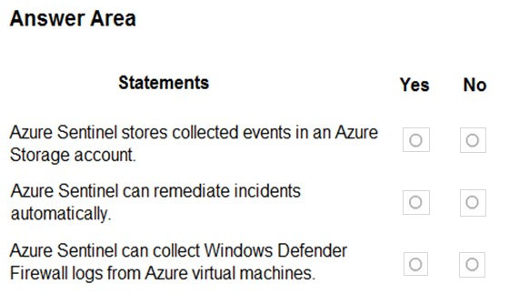

Answer:
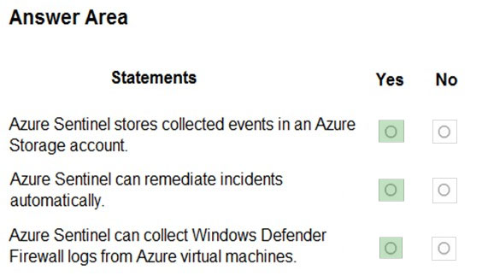

Question 224 Topic 1
DRAG DROP -
Match the Azure Services service to the correct descriptions.
Instructions: To answer, drag the appropriate service from the column on the left to its description on the right. Each service may be used once, more than once, or not at all.
NOTE: Each correct match is worth one point.
Select and Place:
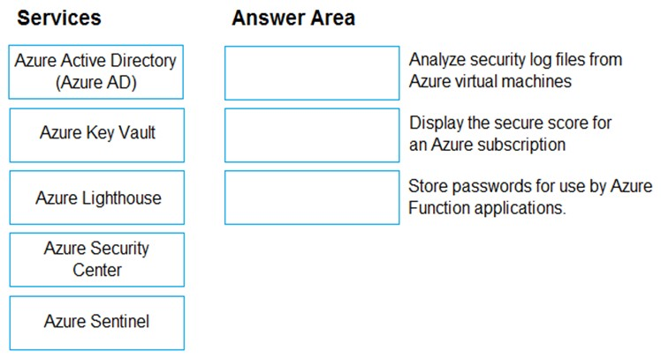

Answer: Incorrect Answer:

Question 225 Topic 1
HOTSPOT -
For each of the following statements, select Yes if the statement is true. Otherwise, select No.
NOTE: Each correct selection is worth one point.
Hot Area:
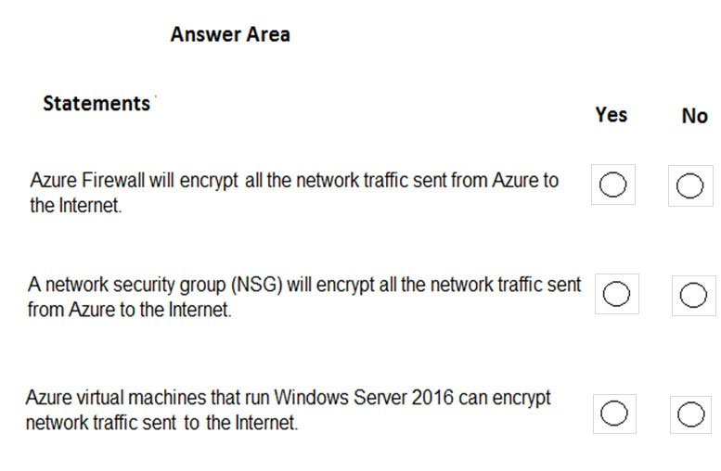

Answer:
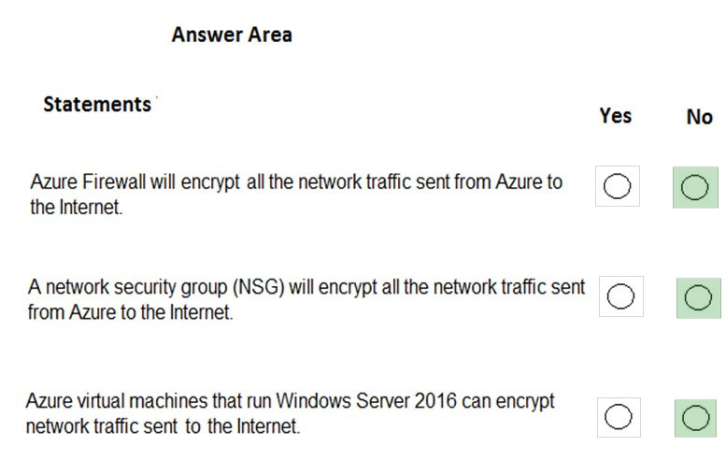

Question 226 Topic 1
HOTSPOT -
For each of the following statements, select Yes if the statement is true. Otherwise, select No.
NOTE: Each correct selection is worth one point.
Hot Area:
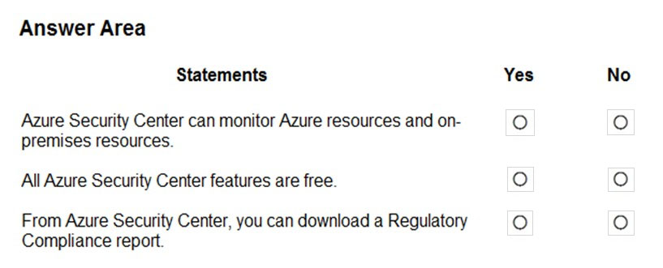

Answer:
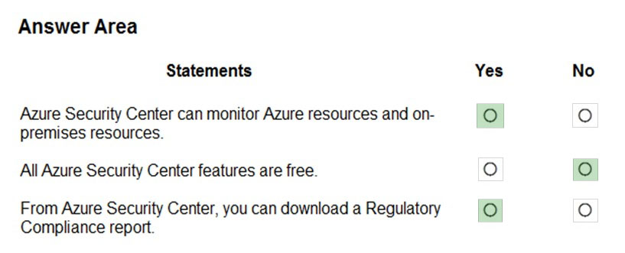

Question 227 Topic 1
DRAG DROP -
You need to complete the defense-in-depth strategy used in a datacenter.
What should you do? To answer, drag the appropriate layers to the correct positions in the model. Each layer may be used once, more than once, or not at all.
You may need to drag the split bar between panes or scroll to view content.
NOTE: Each correct selection is worth one point.
Select and Place:
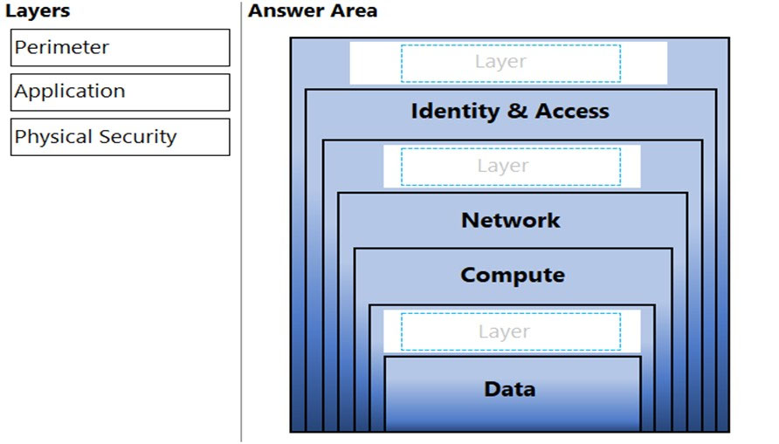

Answer:
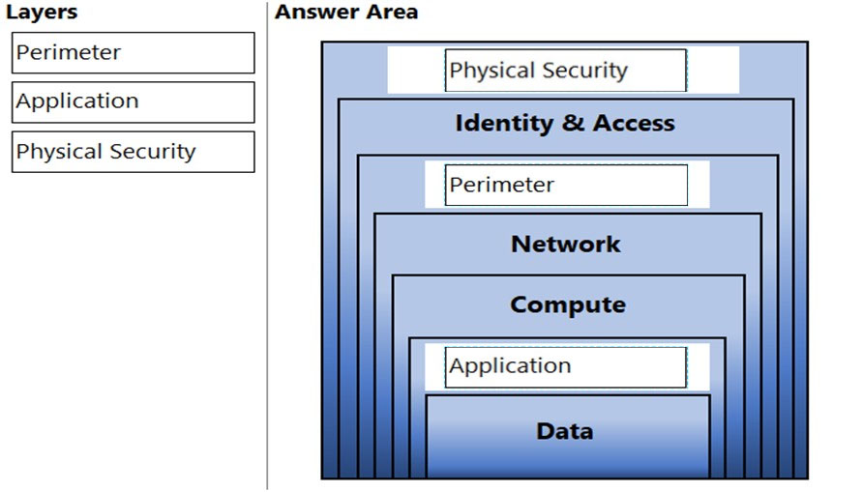

Question 228 Topic 1
You have an Azure virtual machine named VM1.
You plan to encrypt VM1 by using Azure Disk Encryption.
Which Azure resource must you create first?
A. an Azure Storage account
B. an Azure Key Vault
C. an Azure Information Protection policy
D. an Encryption key
Answer: B
Voted Answer: B

Question 229 Topic 1
Which resources can be used as a source for a Network security group inbound security rule?
A. Service Tags only
B. IP Addresses, Service tags and Application security groups
C. Application security groups only
D. IP Addresses only
Answer: B
Voted Answer: B

Question 230 Topic 1
HOTSPOT -
To complete the sentence, select the appropriate option in the answer area.
Hot Area:
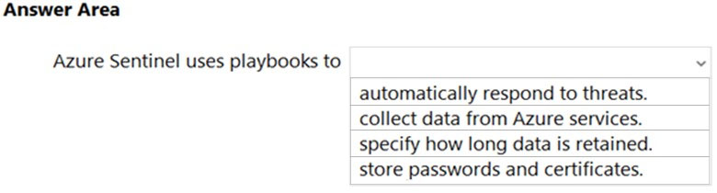

Answer:
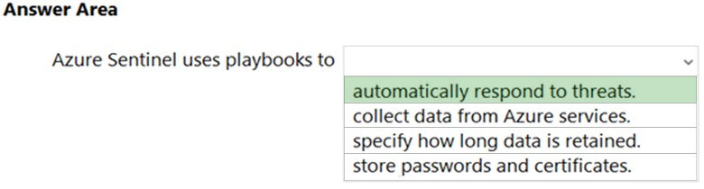

Question 231 Topic 1
HOTSPOT -
To complete the sentence, select the appropriate option in the answer area.
Hot Area:
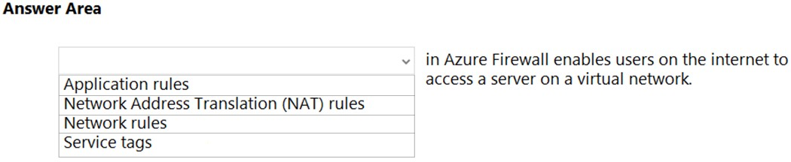

Answer:
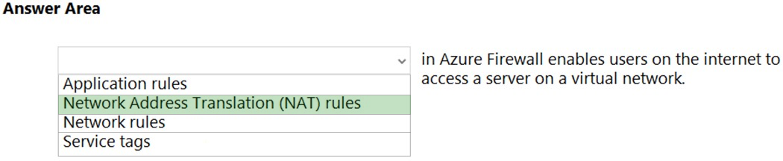

Question 232 Topic 1
HOTSPOT -
To complete the sentence, select the appropriate option in the answer area.
Hot Area:
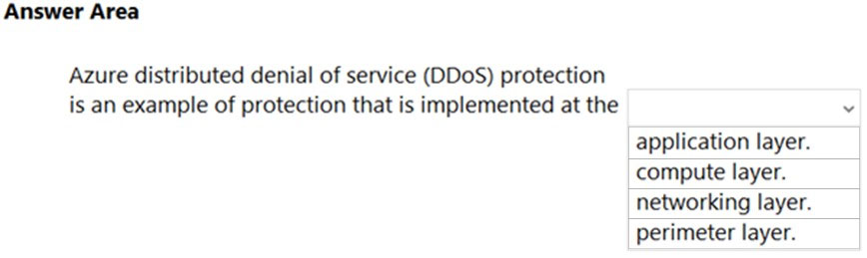

Answer:
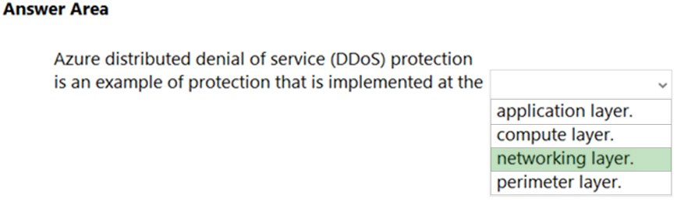

Question 233 Topic 1
You have an Azure Sentinel workspace.
You need to automate responses to threats detected by Azure Sentinel.
What should you use?
A. adaptive network hardening in Azure Security Center
B. Azure Service Health
C. Azure Monitor workbooks
D. adaptive application controls in Azure Security Center
Answer: C
Voted Answer: C

Question 234 Topic 1
DRAG DROP -
Match the Azure services benefits to the correct descriptions.
Instructions: To answer, drag the appropriate benefit from the column on the left to its description on the right. Each benefit may be used once, more than once, or not at all.
NOTE: Each correct match is worth one point.
Select and Place:
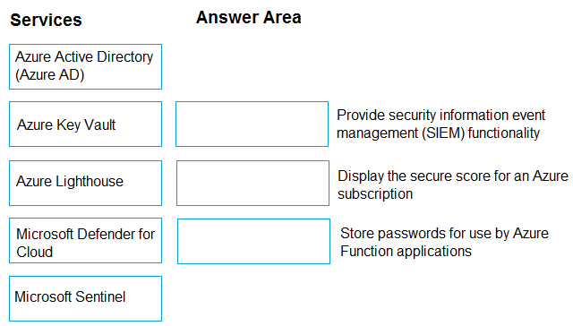

Answer:
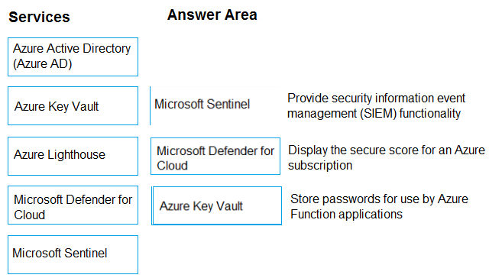

Question 235 Topic 1
Which Azure service can you use as a security information and event management (SIEM) solution?
A. Azure Analysis Services
B. Microsoft Sentinel
C. Azure Information Protection
D. Azure Cognitive Services
Answer: B
Voted Answer: B

Question 236 Topic 1
HOTSPOT -
Select the answer that correctly completes the sentence.
Hot Area:
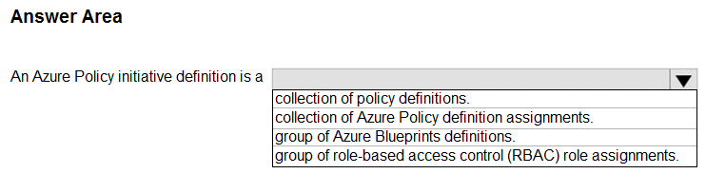

Answer:
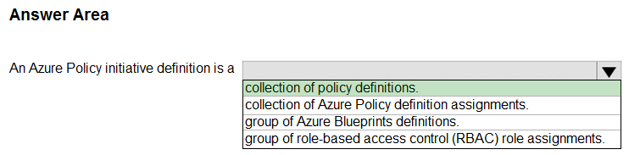

Question 237 Topic 1
You have an Azure subscription.
You need to review your secure score.
What should you use?
A. Azure Monitor
B. Azure Advisor
C. Help + support
D. Microsoft Defender for Cloud
Answer: D
Voted Answer: D

Question 238 Topic 1
HOTSPOT -
Select the answer that correctly completes the sentence.
Hot Area:
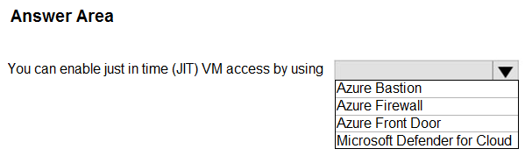

Answer:
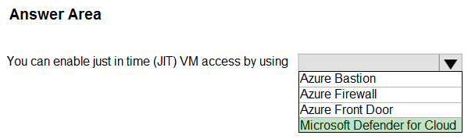

Question 239 Topic 1
HOTSPOT -
Select the answer that correctly completes the sentence.
Hot Area:
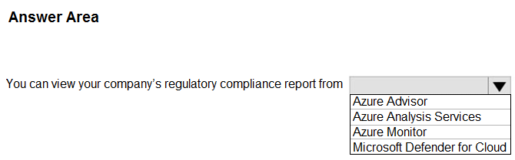

Answer:
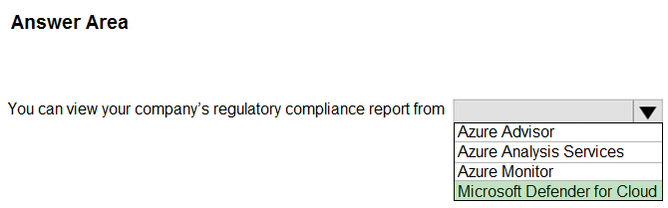

Question 240 Topic 1
You need to collect and automatically analyze security events from Azure Active Directory (Azure AD).
What should you use?
A. Microsoft Sentinel
B. Azure Synapse Analytics
C. Azure AD Connect
D. Azure Key Vault
Answer: A
Voted Answer: A

Question 241 Topic 1
HOTSPOT -
Select the answer that correctly completes the sentence.
Hot Area:
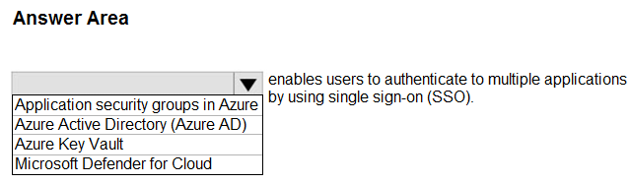

Answer:
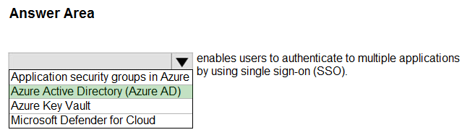

Question 242 Topic 1
HOTSPOT -
For each of the following statements, select Yes if the statement is true. Otherwise, select No.
NOTE: Each correct selection is worth one point.
Hot Area:
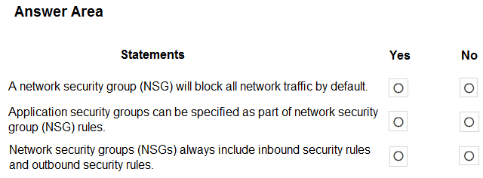

Answer:
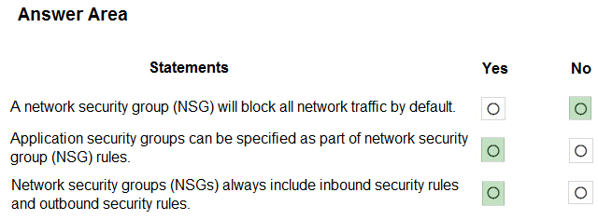

Question 243 Topic 1
DRAG DROP -
Match the term to the appropriate description.
To answer, drag the appropriate term from the column on the left to its description on the right. Each term may be used once, more than once, or not at all.
NOTE: Each correct match is worth one point.
Select and Place:
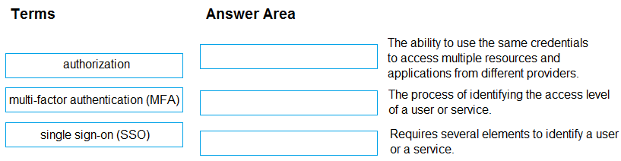

Answer:
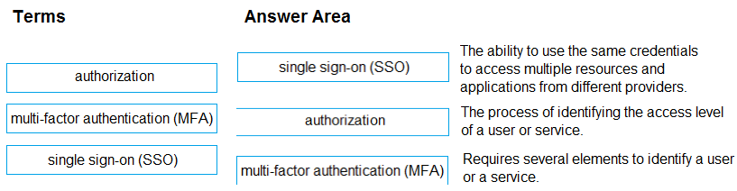

Question 244 Topic 1
Your company plans to automate the deployment of servers to Azure.
Your manager is concerned that you may expose administrative credentials during the deployment.
You need to recommend an Azure solution that encrypts the administrative credentials during the deployment.
What should you include in the recommendation?
A. Azure Key Vault
B. Azure Information Protection
C. Microsoft Defender for Cloud
D. Azure Multi-Factor Authentication (MFA)
Answer: A
Voted Answer: A

Question 245 Topic 1
HOTSPOT -
Select the answer that correctly completes the sentence.
Hot Area:
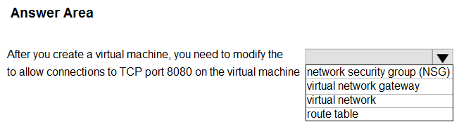

Answer:
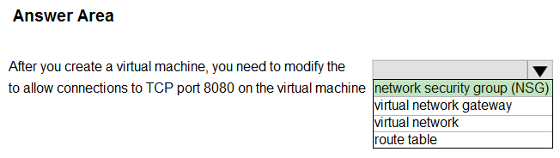

Question 246 Topic 1
HOTSPOT -
Select the answer that correctly completes the sentence.
Hot Area:
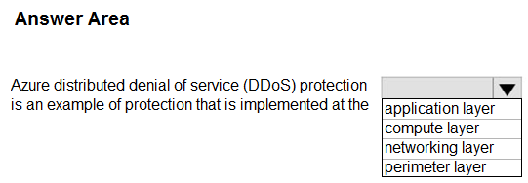

Answer:
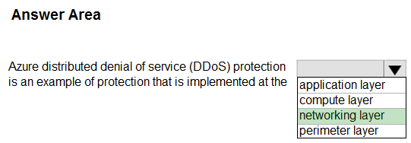

Question 247 Topic 1
HOTSPOT -
Select the answer that correctly completes the sentence.
Hot Area:
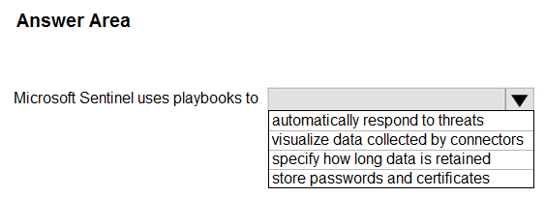

Answer:
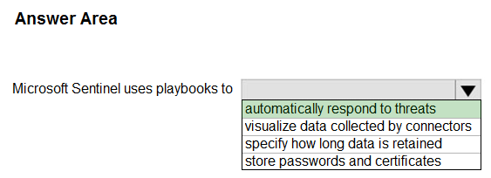

Question 248 Topic 1
You need to configure an Azure solution that meets the following requirements:
✑ Secures websites from attacks
✑ Generates reports that contain details of attempted attacks
What should you include in the solution?
A. Azure Firewall
B. a network security group (NSG)
C. Azure Information Protection
D. DDoS protection
Answer: D
Voted Answer: D

Question 249 Topic 1
HOTSPOT -
You plan to implement several security services for an Azure environment. You need to identify which Azure services must be used to meet the following security requirements:
✑ Monitor threats by using sensors
✑ Enforce Azure Multi-Factor Authentication (MFA) based on a condition
Which Azure service should you identify for each requirement? To answer, select the appropriate options in the answer area.
NOTE: Each correct selection is worth one point.
Hot Area:
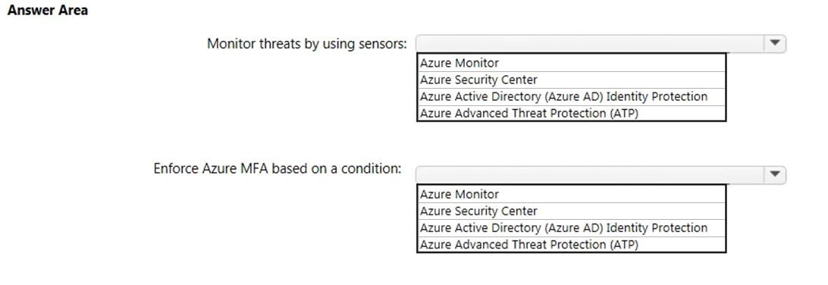

Answer:
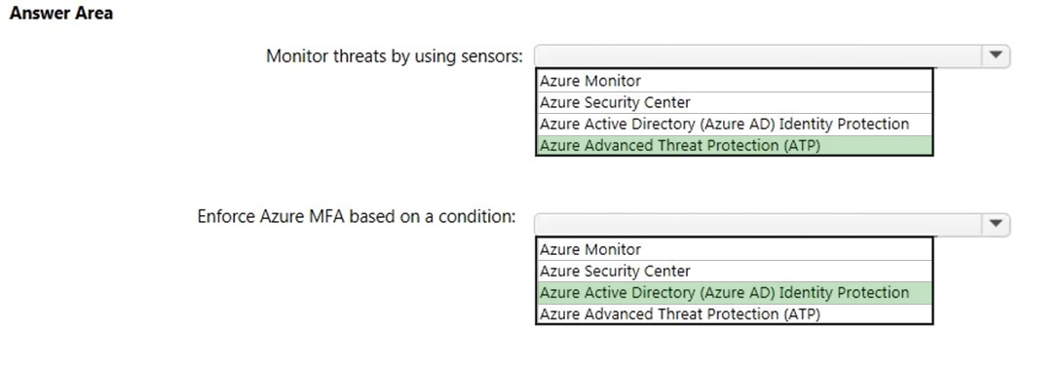

Question 250 Topic 1
Your Azure environment contains multiple Azure virtual machines.
You need to ensure that a virtual machine named VM1 is accessible from the Internet over HTTP.
What are two possible solutions? Each correct answer presents a complete solution.
NOTE: Each correct selection is worth one point.
A. Modify an Azure Traffic Manager profile
B. Modify a network security group (NSG)
C. Modify a DDoS protection plan
D. Modify an Azure firewall
Answer: B
Voted Answer: B

Question 251 Topic 1
HOTSPOT -
To complete the sentence, select the appropriate option in the answer area.
Hot Area:
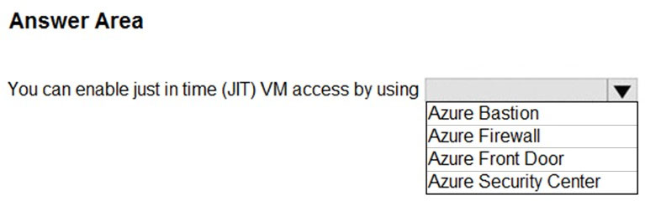

Answer:
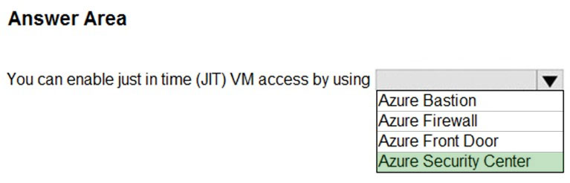

Question 252 Topic 1
HOTSPOT -
For each of the following statements, select Yes if the statement is true. Otherwise, select No.
NOTE: Each correct selection is worth one point.
Hot Area:
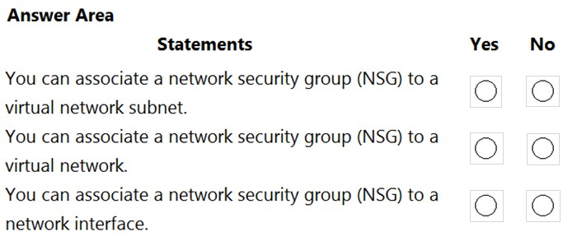

Answer:
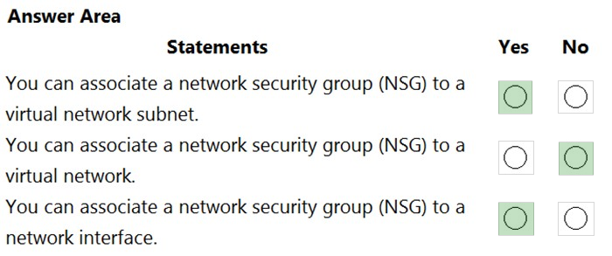

Question 253 Topic 1
You have an Azure environment that contains 10 virtual networks and 100 virtual machines.
You need to limit the amount of inbound traffic to all the Azure virtual networks.
What should you create?
A. one application security group (ASG)
B. 10 virtual network gateways
C. 10 Azure ExpressRoute circuits
D. one Azure firewall
Answer: D
Voted Answer: D

Question 254 Topic 1
This question requires that you evaluate the underlined text to determine if it is correct.
Azure Key Vault is used to store secrets for Azure Active Directory (Azure AD) user accounts.
Instructions: Review the underlined text. If it makes the statement correct, select `No change is needed`. If the statement is incorrect, select the answer choice that makes the statement correct.
A. No change is needed
B. Azure Active Directory (Azure AD) administrative accounts
C. Personally Identifiable Information (PII)
D. server applications
Answer: D
Voted Answer: D

Question 255 Topic 1
Your company plans to automate the deployment of servers to Azure.
Your manager is concerned that you may expose administrative credentials during the deployment.
You need to recommend an Azure solution that encrypts the administrative credentials during the deployment.
What should you include in the recommendation?
A. Azure Key Vault
B. Azure Information Protection
C. Azure Security Center
D. Azure Multi-Factor Authentication (MFA)
Answer: A
Voted Answer: A

Question 256 Topic 1
You plan to deploy several Azure virtual machines.
You need to control the ports that devices on the Internet can use to access the virtual machines.
What should you use?
A. a network security group (NSG)
B. an Azure Active Directory (Azure AD) role
C. an Azure Active Directory group
D. an Azure key vault
Answer: A
Voted Answer: A

Question 257 Topic 1
HOTSPOT -
To complete the sentence, select the appropriate option in the answer area.
Hot Area:
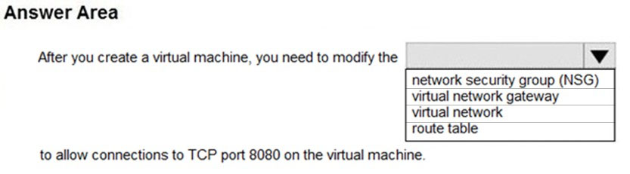

Answer:
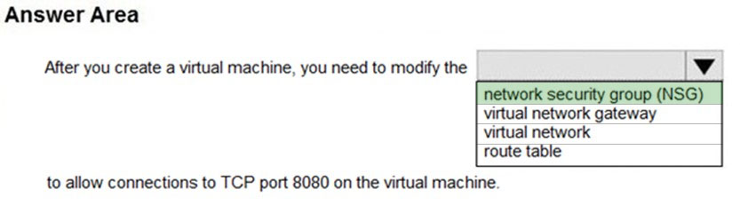

Question 258 Topic 1
HOTSPOT -
For each of the following statements, select Yes if the statement is true. Otherwise, select No.
NOTE: Each correct selection is worth one point.
Hot Area:
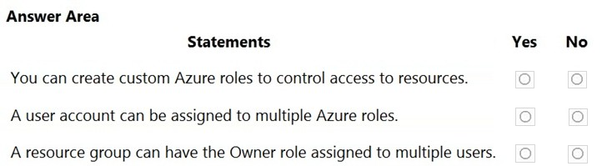

Answer:
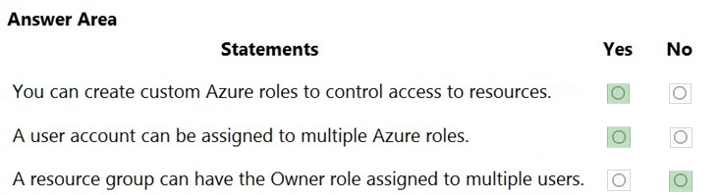

Question 259 Topic 1
Note: This question is part of a series of questions that present the same scenario. Each question in the series contains a unique solution that might meet the stated goals. Some question sets might have more than one correct solution, while others might not have a correct solution.
After you answer a question in this section, you will NOT be able to return to it. As a result, these questions will not appear in the review screen.
Your Azure environment contains multiple Azure virtual machines.
You need to ensure that a virtual machine named VM1 is accessible from the Internet over HTTP.
Solution: You modify a network security group (NSG).
Does this meet the goal?
A. Yes
B. No
Answer: A
Voted Answer: A

Question 260 Topic 1
Note: This question is part of a series of questions that present the same scenario. Each question in the series contains a unique solution that might meet the stated goals. Some question sets might have more than one correct solution, while others might not have a correct solution.
After you answer a question in this section, you will NOT be able to return to it. As a result, these questions will not appear in the review screen.
Your Azure environment contains multiple Azure virtual machines.
You need to ensure that a virtual machine named VM1 is accessible from the Internet over HTTP.
Solution: You modify a DDoS protection plan.
Does this meet the goal?
A. Yes
B. No
Answer: B
Voted Answer: B

Question 261 Topic 1
You need to collect and automatically analyze security events from Azure Active Directory (Azure AD).
What should you use?
A. Azure Sentinel
B. Azure Synapse Analytics
C. Azure AD Connect
D. Azure Key Vault
Answer: A
Voted Answer: A

Question 262 Topic 1
Note: This question is part of a series of questions that present the same scenario. Each question in the series contains a unique solution that might meet the stated goals. Some question sets might have more than one correct solution, while others might not have a correct solution.
After you answer a question in this section, you will NOT be able to return to it. As a result, these questions will not appear in the review screen.
Your Azure environment contains multiple Azure virtual machines.
You need to ensure that a virtual machine named VM1 is accessible from the Internet over HTTP.
Solution: You modify an Azure firewall.
Does this meet the goal?
A. Yes
B. No
Answer: B
Voted Answer: B

Question 263 Topic 1
This question requires that you evaluate the underlined text to determine if it is correct.
Azure Germany can be used by legal residents of Germany only.
Instructions: Review the underlined text. If it makes the statement correct, select `No change is needed`. If the statement is incorrect, select the answer choice that makes the statement correct.
A. no change is needed
B. only enterprises that are registered in Germany
C. only enterprises that purchase their azure licenses from a partner based in Germany
D. any user or enterprise that requires its data to reside in Germany
Answer: D
Voted Answer: D

Question 264 Topic 1
HOTSPOT -
For each of the following statements, select Yes if the statement is true. Otherwise, select No.
NOTE: Each correct selection is worth one point.
Hot Area:
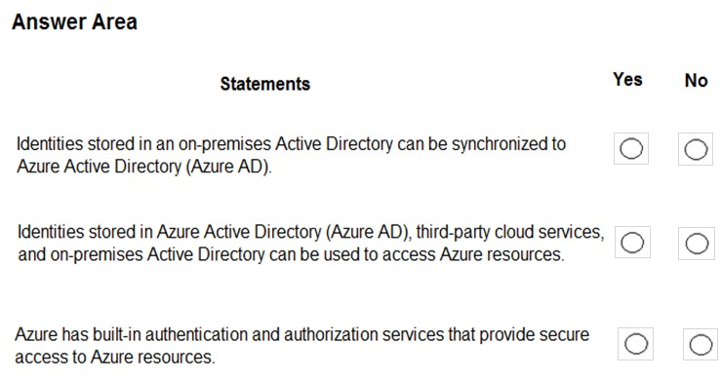

Answer:
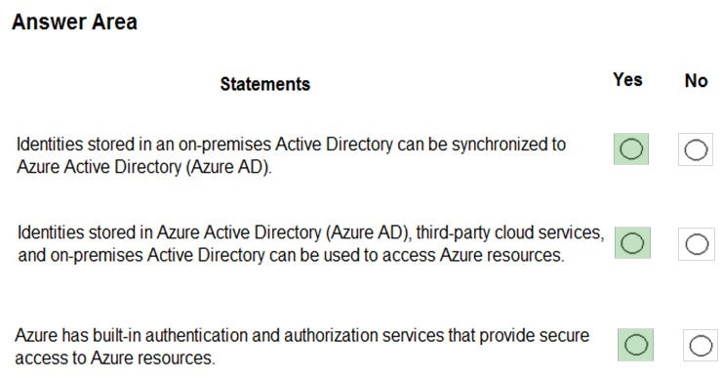

Question 265 Topic 1
HOTSPOT -
To complete the sentence, select the appropriate option in the answer area.
Hot Area:
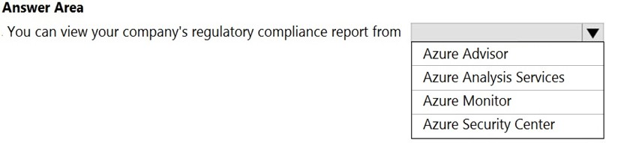

Answer:
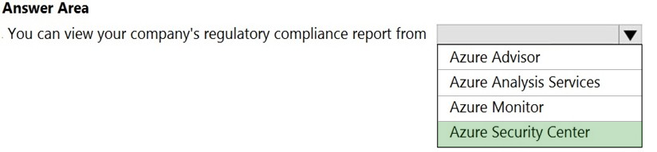

Question 266 Topic 1
HOTSPOT -
For each of the following statements, select Yes if the statement is true. Otherwise, select No.
NOTE: Each correct selection is worth one point.
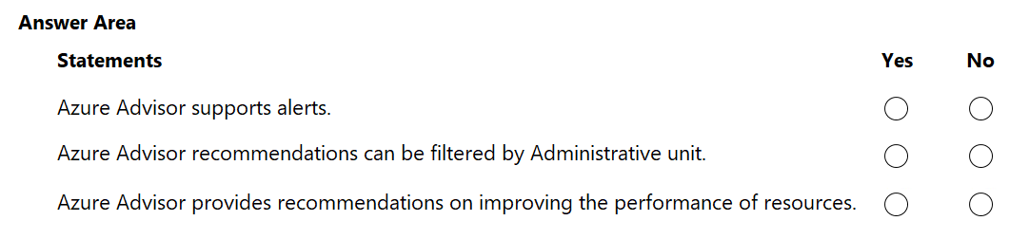
Answer:
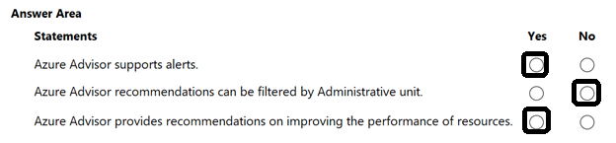

Question 267 Topic 1
HOTSPOT -
To complete the sentence, select the appropriate option in the answer area.
Hot Area:
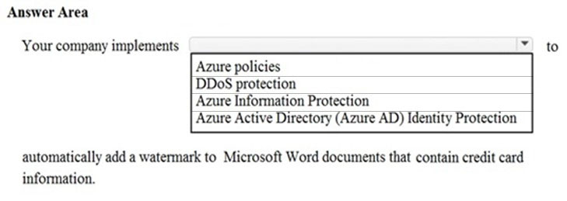

Answer:
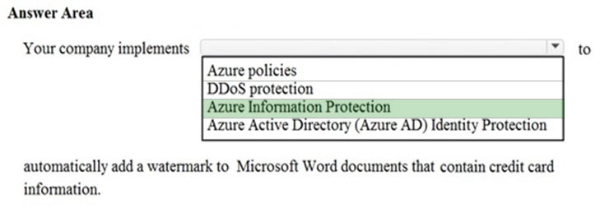

Question 268 Topic 1
HOTSPOT -
For each of the following statements, select Yes if the statement is true. Otherwise, select No.
NOTE: Each correct selection is worth one point.
Hot Area:
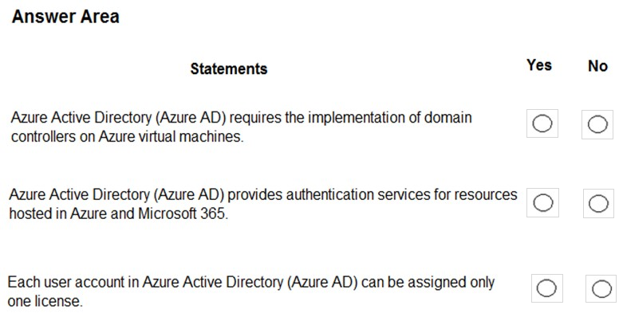

Answer:
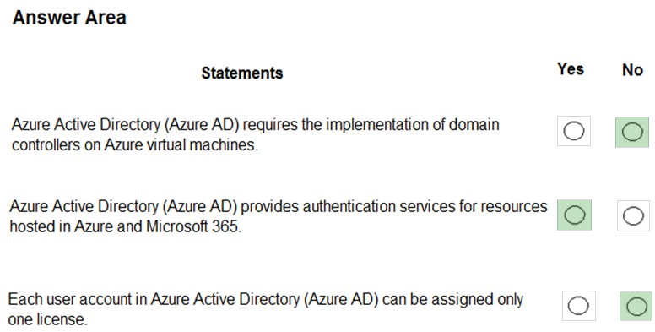

Question 269 Topic 1
Which two types of customers are eligible to use Azure Government to develop a cloud solution? Each correct answer presents a complete solution.
NOTE: Each correct selection is worth one point.
A. a Canadian government contractor
B. a European government contractor
C. a United States government entity
D. a United States government contractor
E. a European government entity
Answer: CD
Voted Answer: CD

Question 270 Topic 1
HOTSPOT -
For each of the following statements, select Yes if the statement is true. Otherwise, select No.
NOTE: Each correct selection is worth one point.
Hot Area:
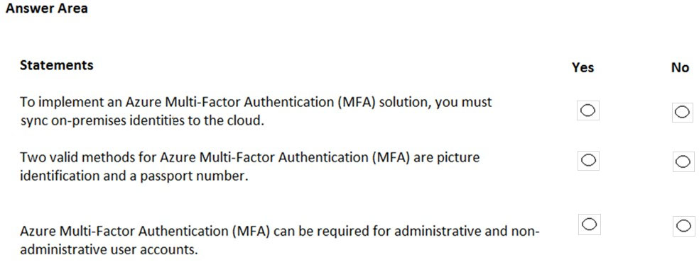

Answer:
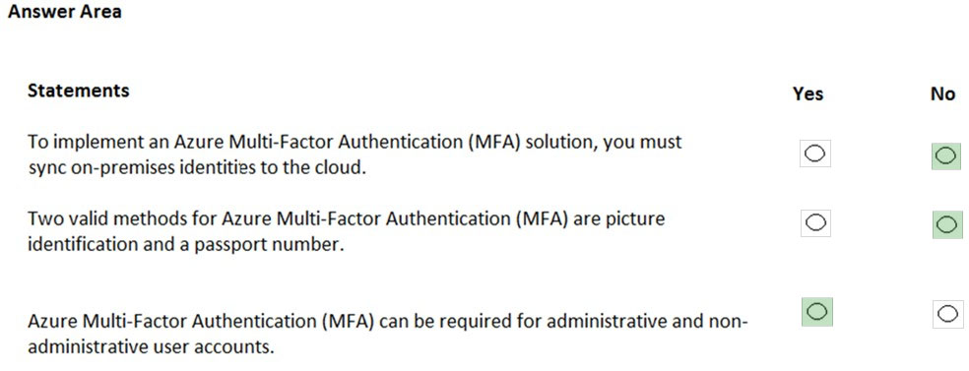

Question 271 Topic 1
You need to ensure that when Azure Active Directory (Azure AD) users connect to Azure AD from the Internet by using an anonymous IP address, the users are prompted automatically to change their password.
Which Azure service should you use?
A. Azure AD Connect Health
B. Azure AD Privileged Identity Management
C. Azure Advanced Threat Protection (ATP)
D. Azure AD Identity Protection
Answer: D
Voted Answer: D

Question 272 Topic 1
DRAG DROP -
Match the term to the correct definition.
Instructions: To answer, drag the appropriate term from the column on the left to its description on the right. Each term may be used once, more than once, or not at all.
NOTE: Each correct match is worth one point.
Select and Place:
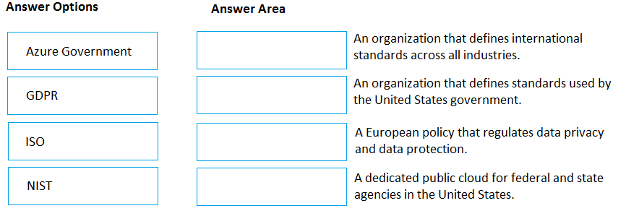

Answer:
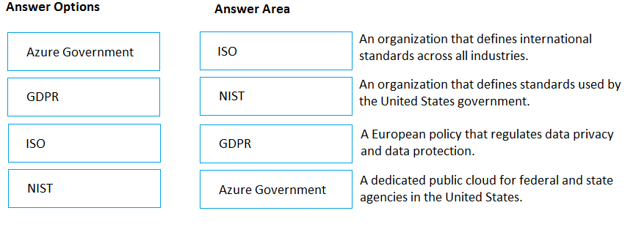

Question 273 Topic 1
To what should an application connect to retrieve security tokens?
A. an Azure Storage account
B. Azure Active Directory (Azure AD)
C. a certificate store
D. an Azure key vault
Answer: B
Voted Answer: B

Question 274 Topic 1
Your network contains an Active Directory forest. The forest contains 5,000 user accounts.
Your company plans to migrate all network resources to Azure and to decommission the on-premises data center.
You need to recommend a solution to minimize the impact on users after the planned migration.
What should you recommend?
A. Implement Azure Multi-Factor Authentication (MFA)
B. Sync all the Active Directory user accounts to Azure Active Directory (Azure AD)
C. Instruct all users to change their password
D. Create a guest user account in Azure Active Directory (Azure AD) for each user
Answer: B
Voted Answer: B

Question 275 Topic 1
HOTSPOT -
For each of the following statements, select Yes if the statement is true. Otherwise, select No.
NOTE: Each correct selection is worth one point.
Hot Area:
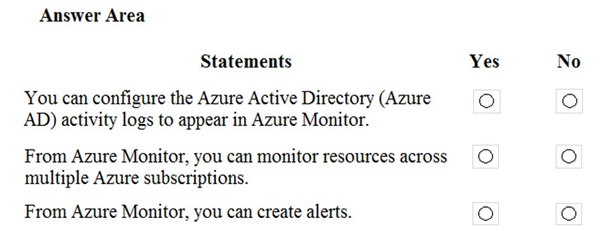

Answer:
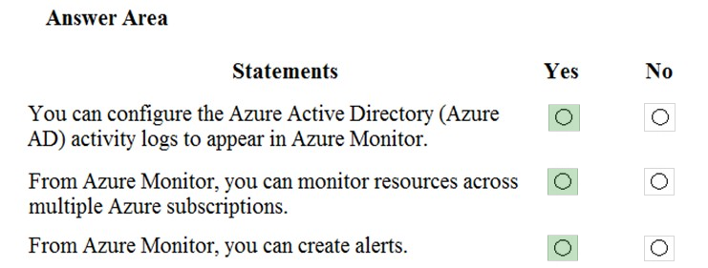

Question 276 Topic 1
HOTSPOT -
You create a resource group named RG1 in Azure Resource Manager.
You need to prevent the accidental deletion of the resources in RG1.
Which setting should you use? To answer, select the appropriate setting in the answer area.
Hot Area:
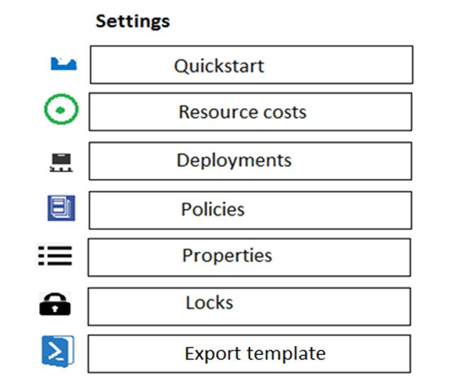

Answer:
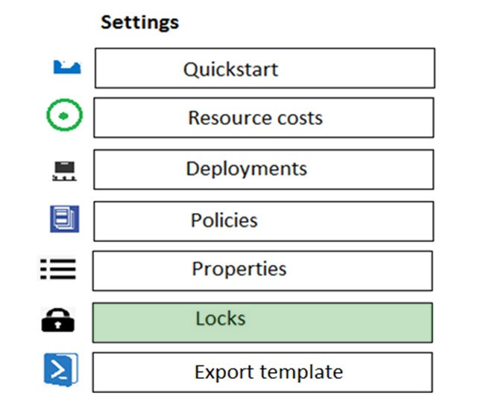

Question 277 Topic 1
You have a resource group named RG1.
You need to prevent the creation of virtual machines in RG1. The solution must ensure that other objects can be created in RG1.
What should you use?
A. a lock
B. an Azure role
C. a tag
D. an Azure policy
Answer: D
Voted Answer: D

Question 278 Topic 1
You have an Azure subscription and 100 Windows 10 devices.
You need to ensure that only users whose devices have the latest security patches installed can access Azure Active Directory (Azure AD)-integrated applications.
What should you implement?
A. a conditional access policy
B. Azure Bastion
C. Azure Firewall
D. Azure Policy
Answer: A
Voted Answer: A

Question 279 Topic 1
What can Azure Information Protection encrypt?
A. network traffic
B. documents and email messages
C. an Azure Storage account
D. an Azure SQL database
Answer: B
Voted Answer: B

Question 280 Topic 1
What should you use to evaluate whether your company's Azure environment meets regulatory requirements?
A. the Knowledge Center website
B. the Advisor blade from the Azure portal
C. Compliance Manager from the Service Trust Portal
D. the Solutions blade from the Azure portal
Answer: C
Voted Answer: D

Question 281 Topic 1
HOTSPOT -
To complete the sentence, select the appropriate option in the answer area.
Hot Area:
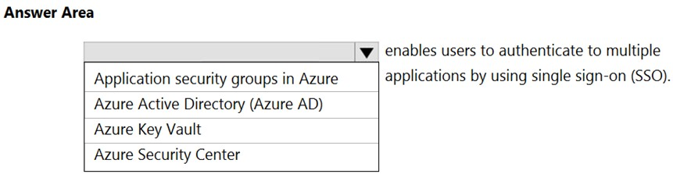

Answer:
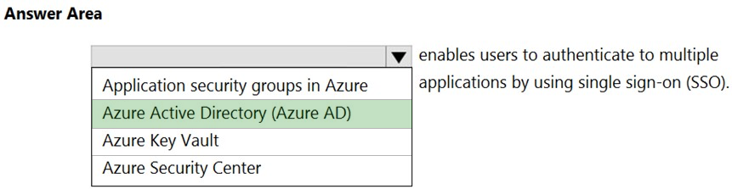

Question 282 Topic 1
You have an Azure subscription.
Where will you find details on the personal data collected by Microsoft, how Microsoft uses the data, and what the data is used for?
A. the Data Protection Addendum
B. the Microsoft Online Services Terms
C. the Microsoft Privacy Statement
D. Azure Security Center
Answer: C
Voted Answer: C

Question 283 Topic 1
HOTSPOT -
For each of the following statements, select Yes if the statement is true. Otherwise, select No.
NOTE: Each correct selection is worth one point.
Hot Area:
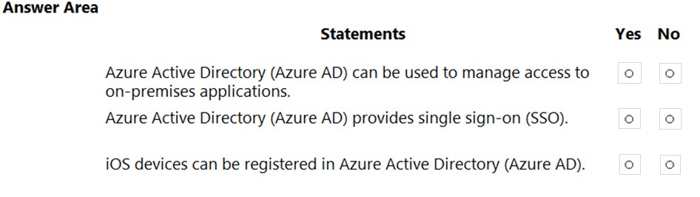

Answer:
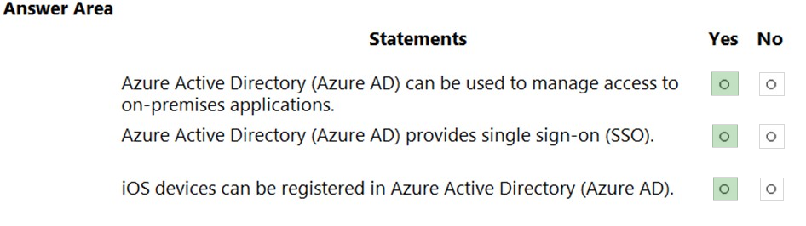

Question 284 Topic 1
HOTSPOT -
To complete the sentence, select the appropriate option in the answer area.
Hot Area:
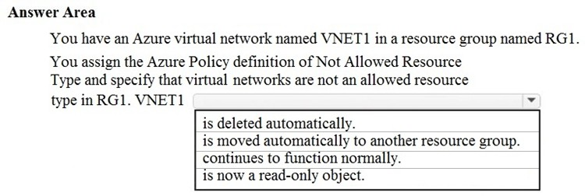

Answer:
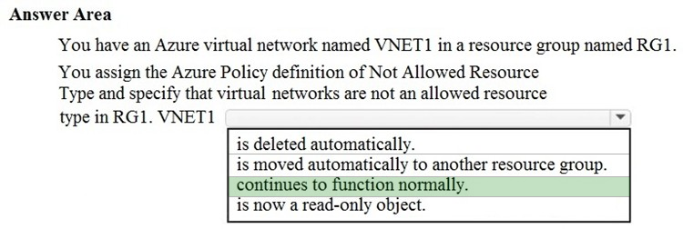

Question 285 Topic 1
HOTSPOT -
For each of the following statements, select Yes if the statement is true. Otherwise, select No.
NOTE: Each correct selection is worth one point.
Hot Area:
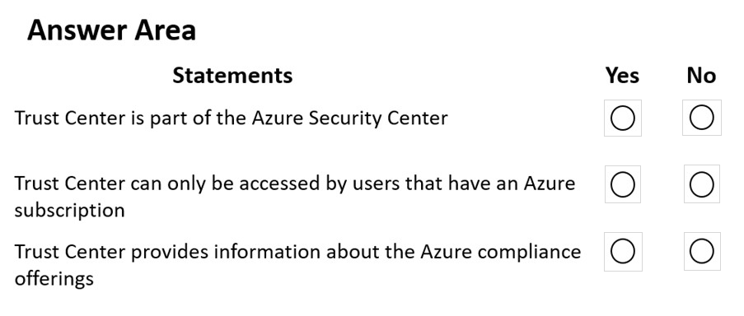

Answer:
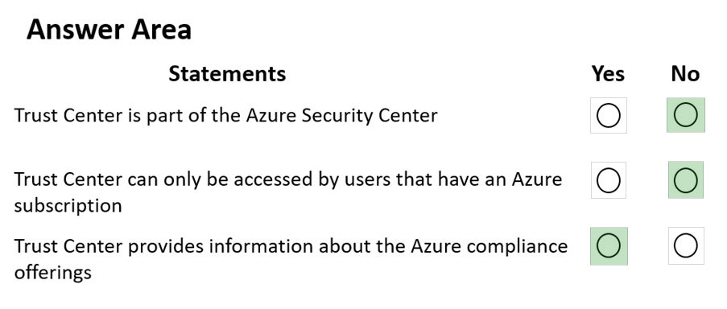

Question 286 Topic 1
HOTSPOT -
For each of the following statements, select Yes if the statement is true. Otherwise, select No.
NOTE: Each correct selection is worth one point.
Hot Area:
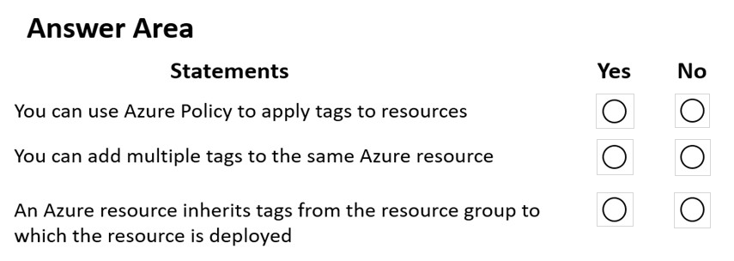

Answer:
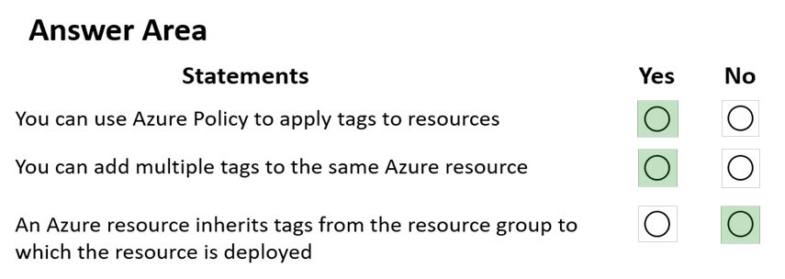

Question 287 Topic 1
DRAG DROP -
Match the resources to the appropriate descriptions.
To answer, drag the appropriate resource from the column on the left to its description on the right. Each resource may be used once, more than once, or not at all.
NOTE: Each correct match is worth one point.
Select and Place:
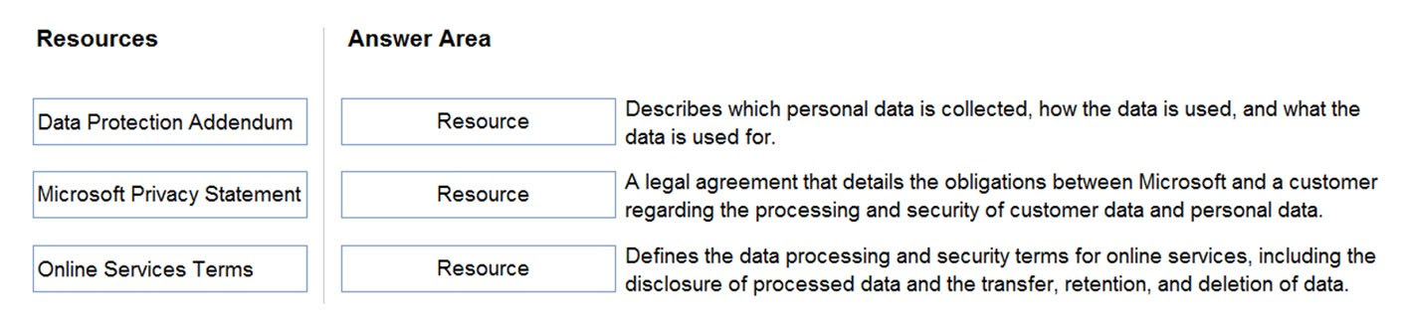

Answer:
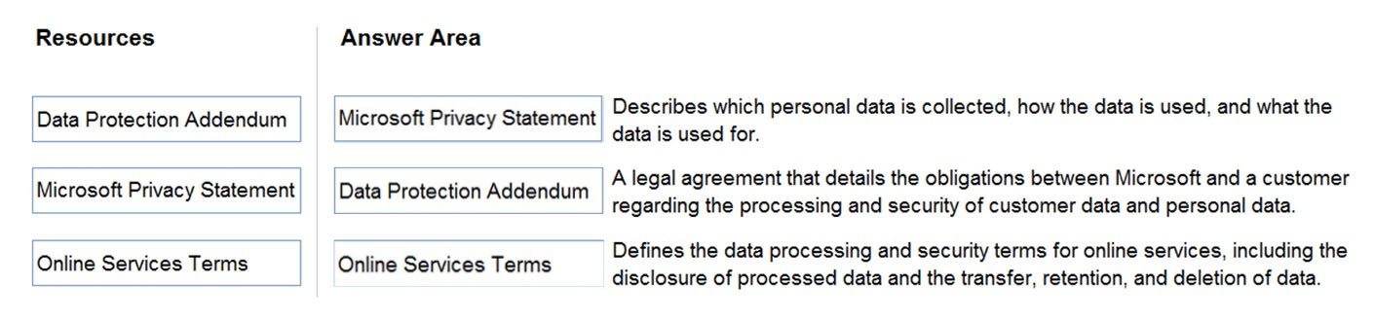

Question 288 Topic 1
HOTSPOT -
Select the answer that correctly completes the sentence.
Hot Area:
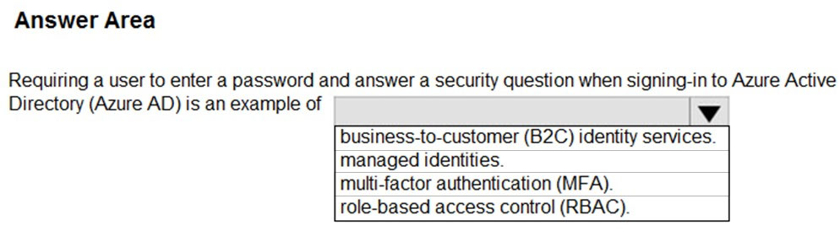

Answer:
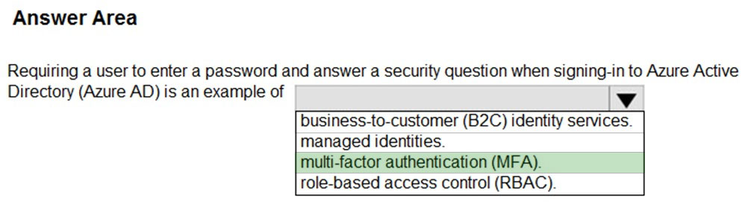

Question 289 Topic 1
HOTSPOT -
Select the answer that correctly completes the sentence.
Hot Area:
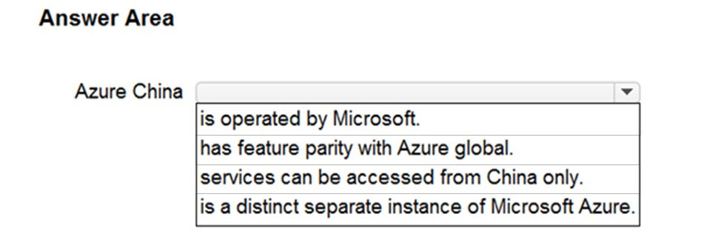

Answer:
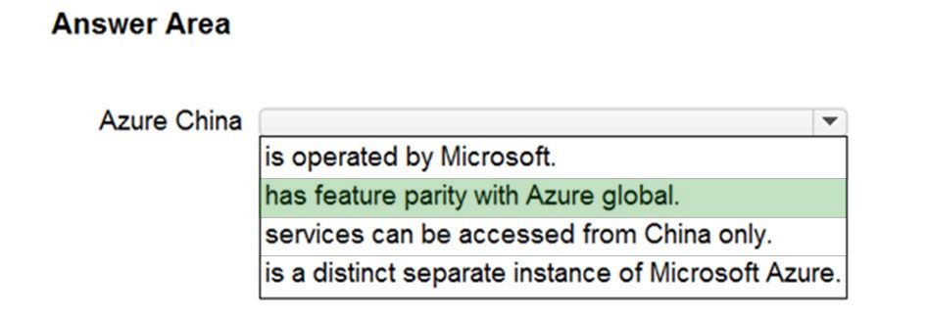

Question 290 Topic 1
What should you use to evaluate whether your company's Azure environment meets regulatory requirements?
A. Azure Service Health
B. Azure Knowledge Center
C. Microsoft Defender for Cloud
D. Azure Advisor
Answer: C
Voted Answer: C

Question 291 Topic 1
HOTSPOT -
Select the answer that correctly completes the sentence.
Hot Area:
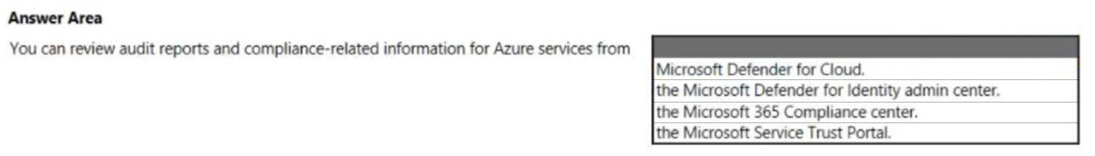

Answer:
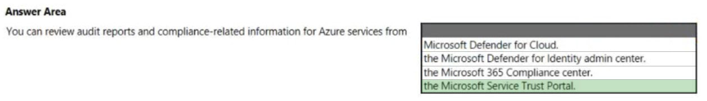

Question 292 Topic 1
HOTSPOT -
For each of the following statements, select Yes if the statement is true. Otherwise, select No.
NOTE: Each correct selection is worth one point.
Hot Area:
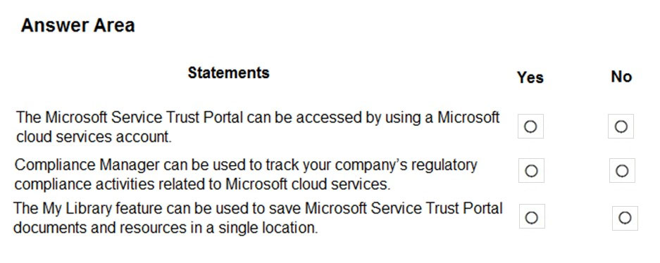

Answer:
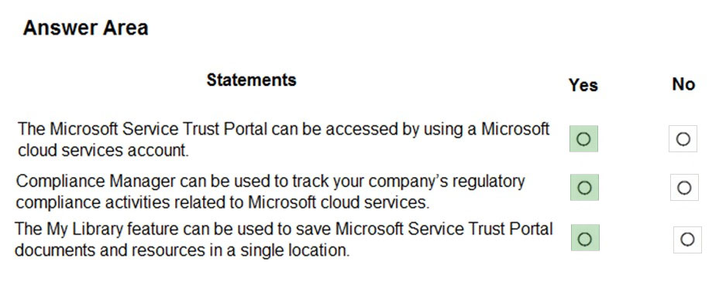

Question 293 Topic 1
Your company has an Azure subscription that contains resources in several regions.
You need to create the Azure resource that must be used to meet the policy requirement.
What should you create?
A. a read-only lock
B. an Azure policy
C. a management group
D. a reservation
Answer: B
Voted Answer: B

Question 294 Topic 1
This question requires that you evaluate the underlined text to determine if it is correct.
From Azure Cloud Shell, you can track your company's regulatory standards and regulations, such as ISO 27001.
Instructions: Review the underlined text. If it makes the statement correct, select `No change is needed.` If the statement is incorrect, select the answer choice that makes the statement correct.
A. No change is needed.
B. the Microsoft Cloud Partner Portal
C. Compliance Manager
D. the Trust Center
Answer: C
Voted Answer: C

Question 295 Topic 1
HOTSPOT -
For each of the following statements, select Yes if the statement is true. Otherwise, select No.
NOTE: Each correct selection is worth one point.
Hot Area:
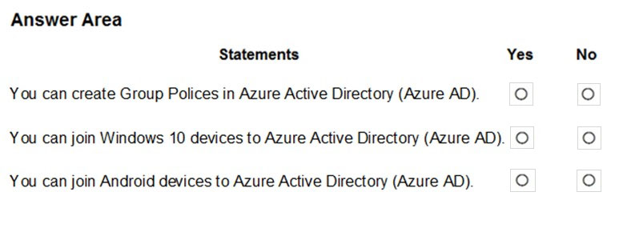

Answer:
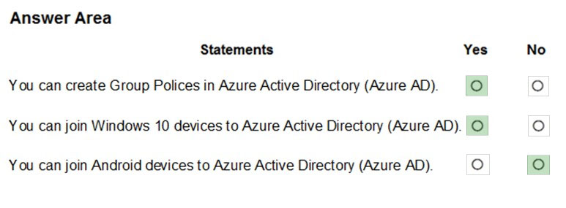

Question 296 Topic 1
HOTSPOT -
To complete the sentence, select the appropriate option in the answer area.
Hot Area:
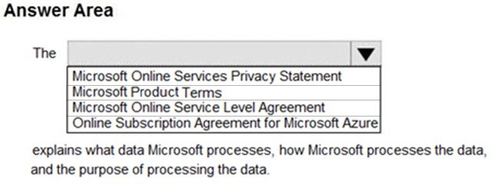

Answer:
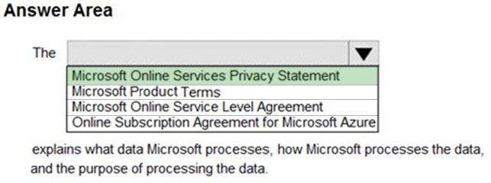

Question 297 Topic 1
HOTSPOT -
To complete the sentence, select the appropriate option in the answer area.
Hot Area:
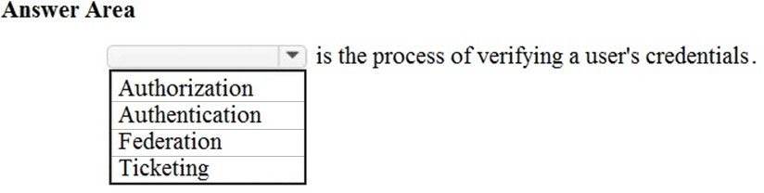

Answer:
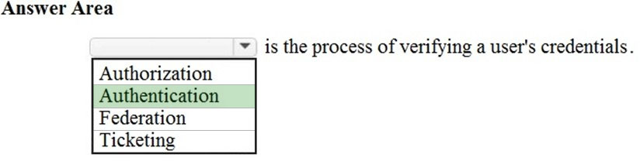

Question 298 Topic 1
HOTSPOT -
To complete the sentence, select the appropriate option in the answer area.
Hot Area:
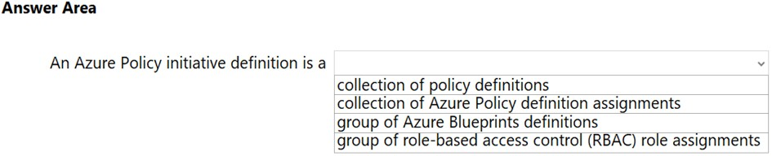

Answer:
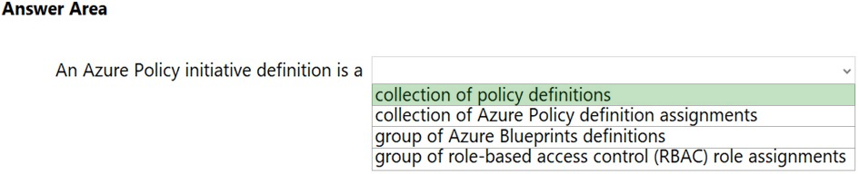

Question 299 Topic 1
HOTSPOT -
To complete the sentence, select the appropriate option in the answer area.
Hot Area:
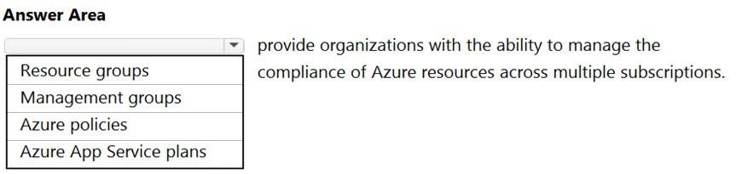

Answer:
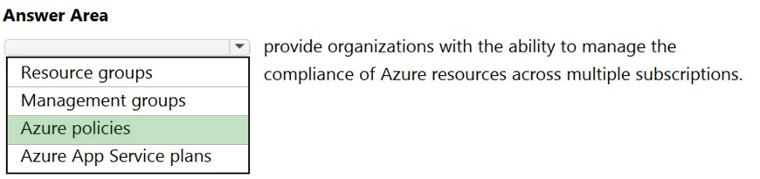

Question 300 Topic 1
HOTSPOT -
For each of the following statements, select Yes if the statement is true. Otherwise, select No.
NOTE: Each correct selection is worth one point.
Hot Area:
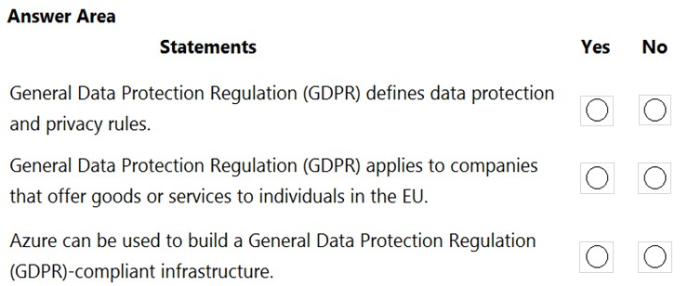

Answer:
